**1. Create instances on cloud:**

(a) Create a lease.

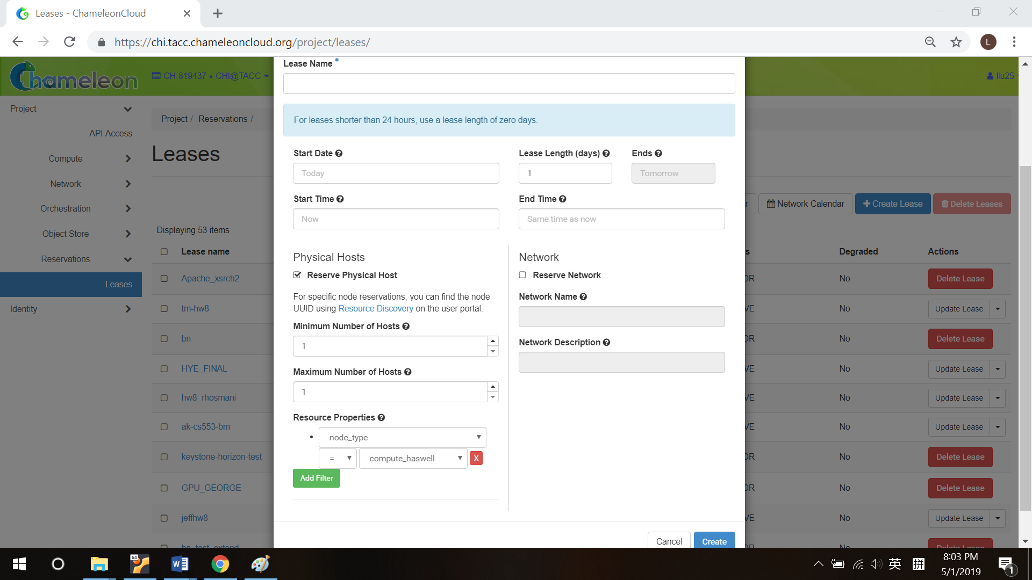

(b) Set up instance name, select your lease, and choose instance number.

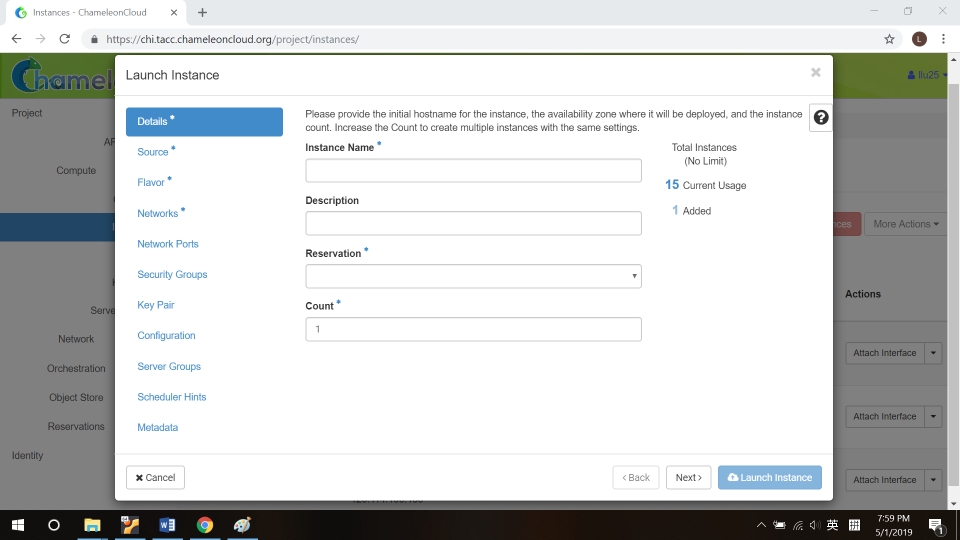

(c) Choose an image. It can be a new operating system, or a snapshot.

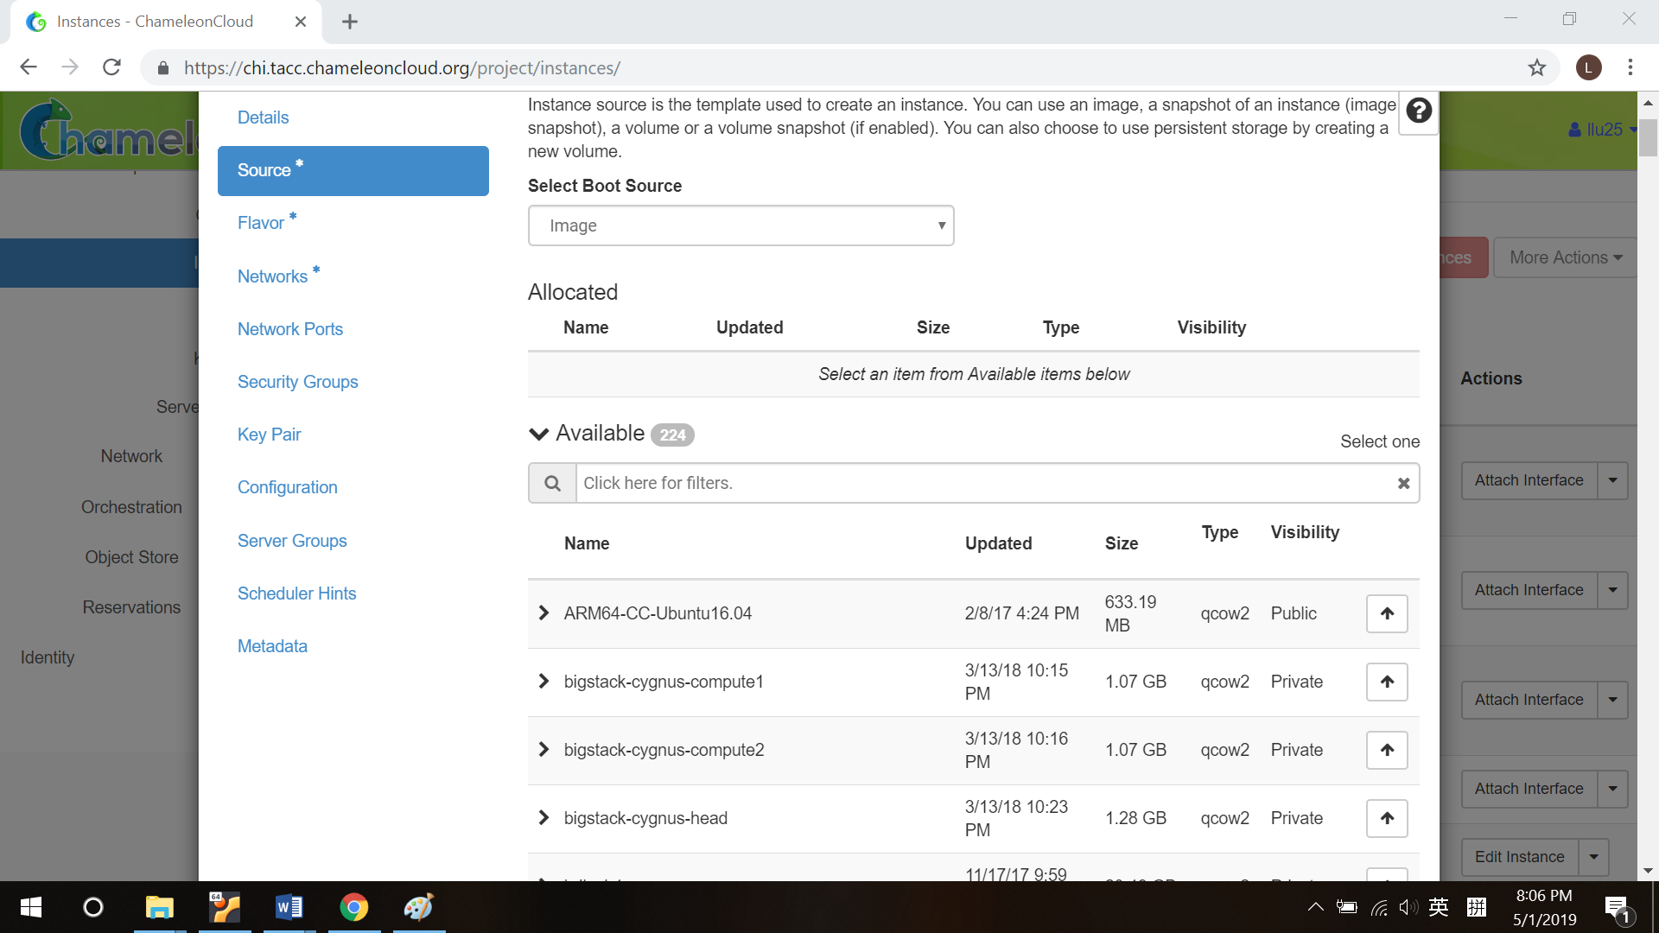

(d) Server type, there is one choice.

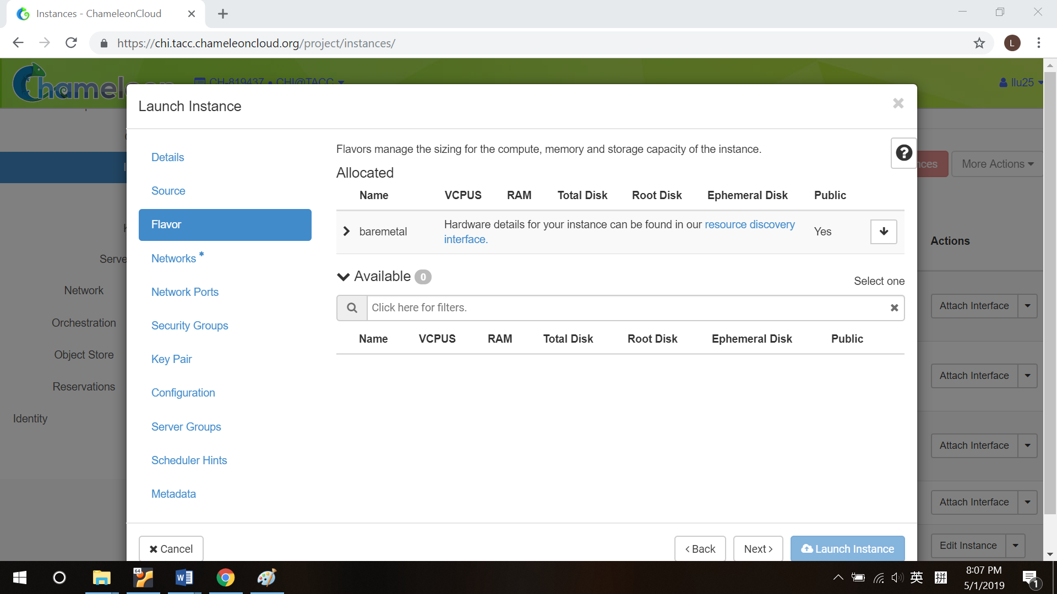

(e) Network. You can create your own network and use it, or use shared network (already created by other people).

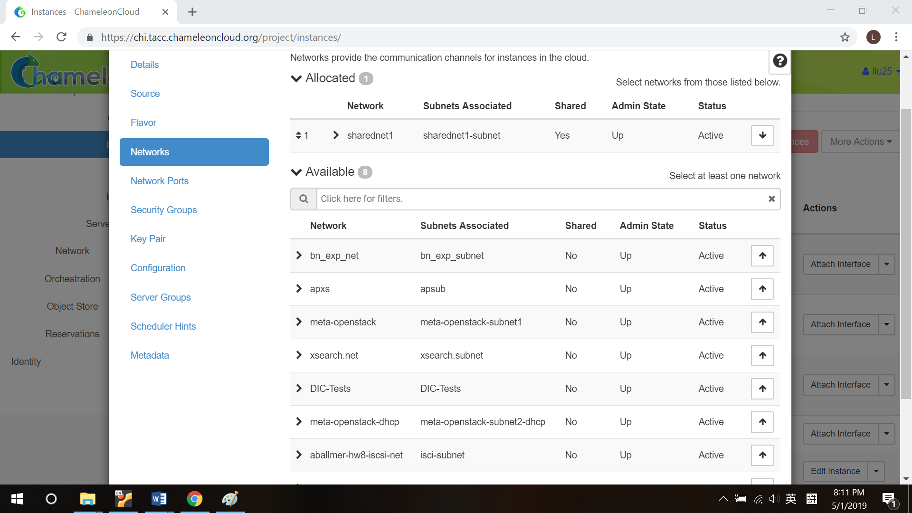

(f) Upload or paste your public keys to remote server. Each machine has different public keys. Server won’t allow connection (for example, ssh) if it doesn’t know your public key.

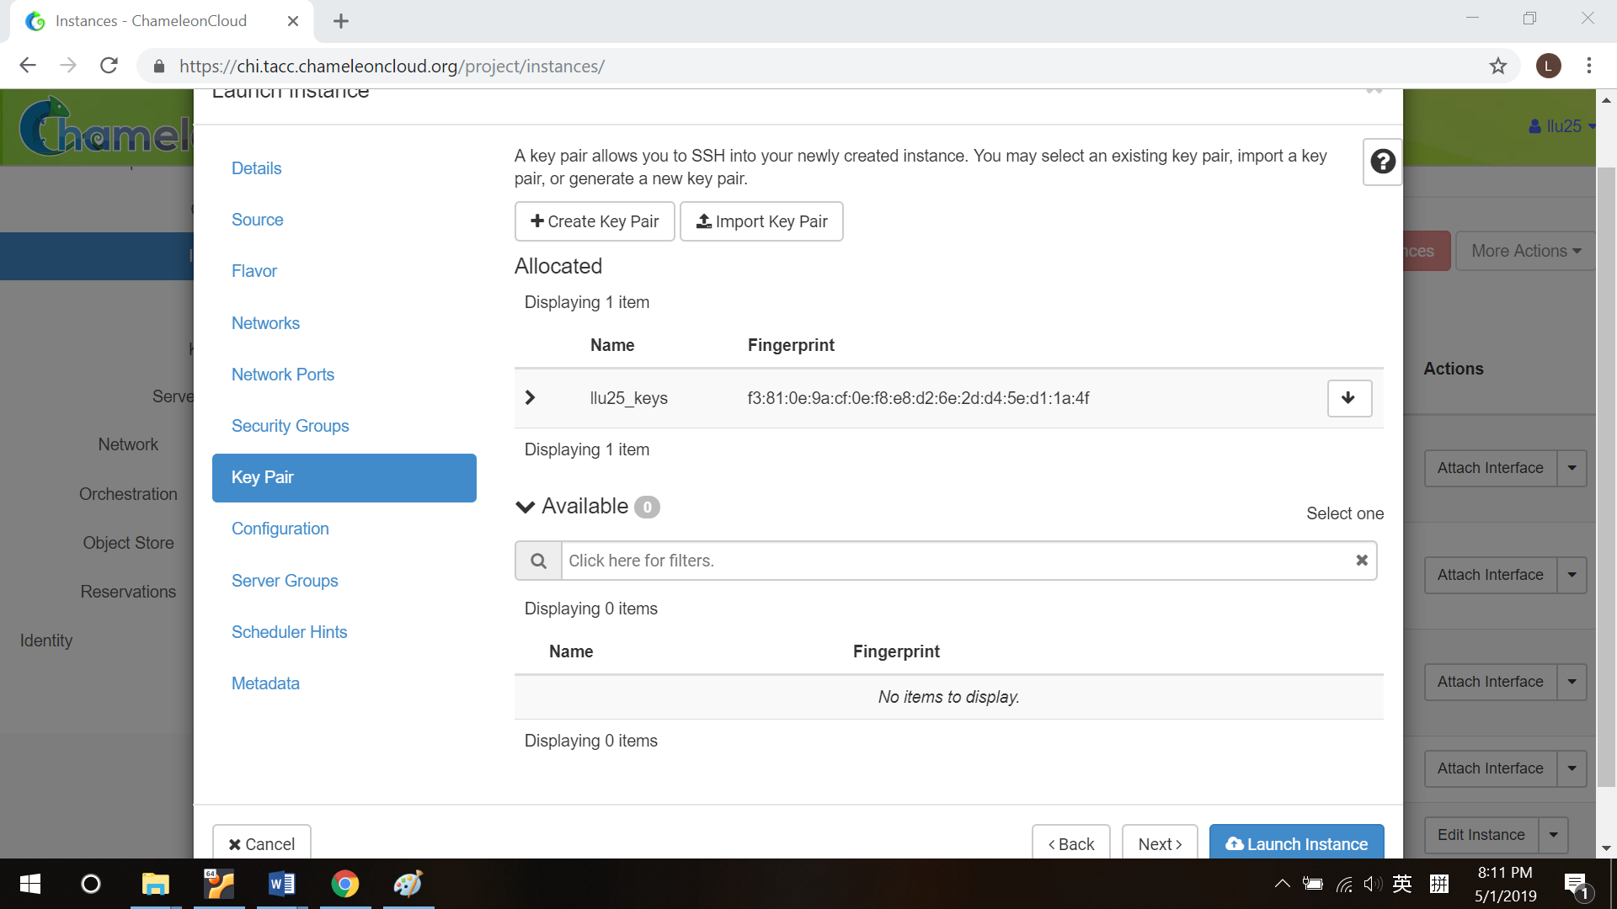

(g) Launch the instance. It’ll take about half an hour.

(h) Generate float IP and associate it to your instance.

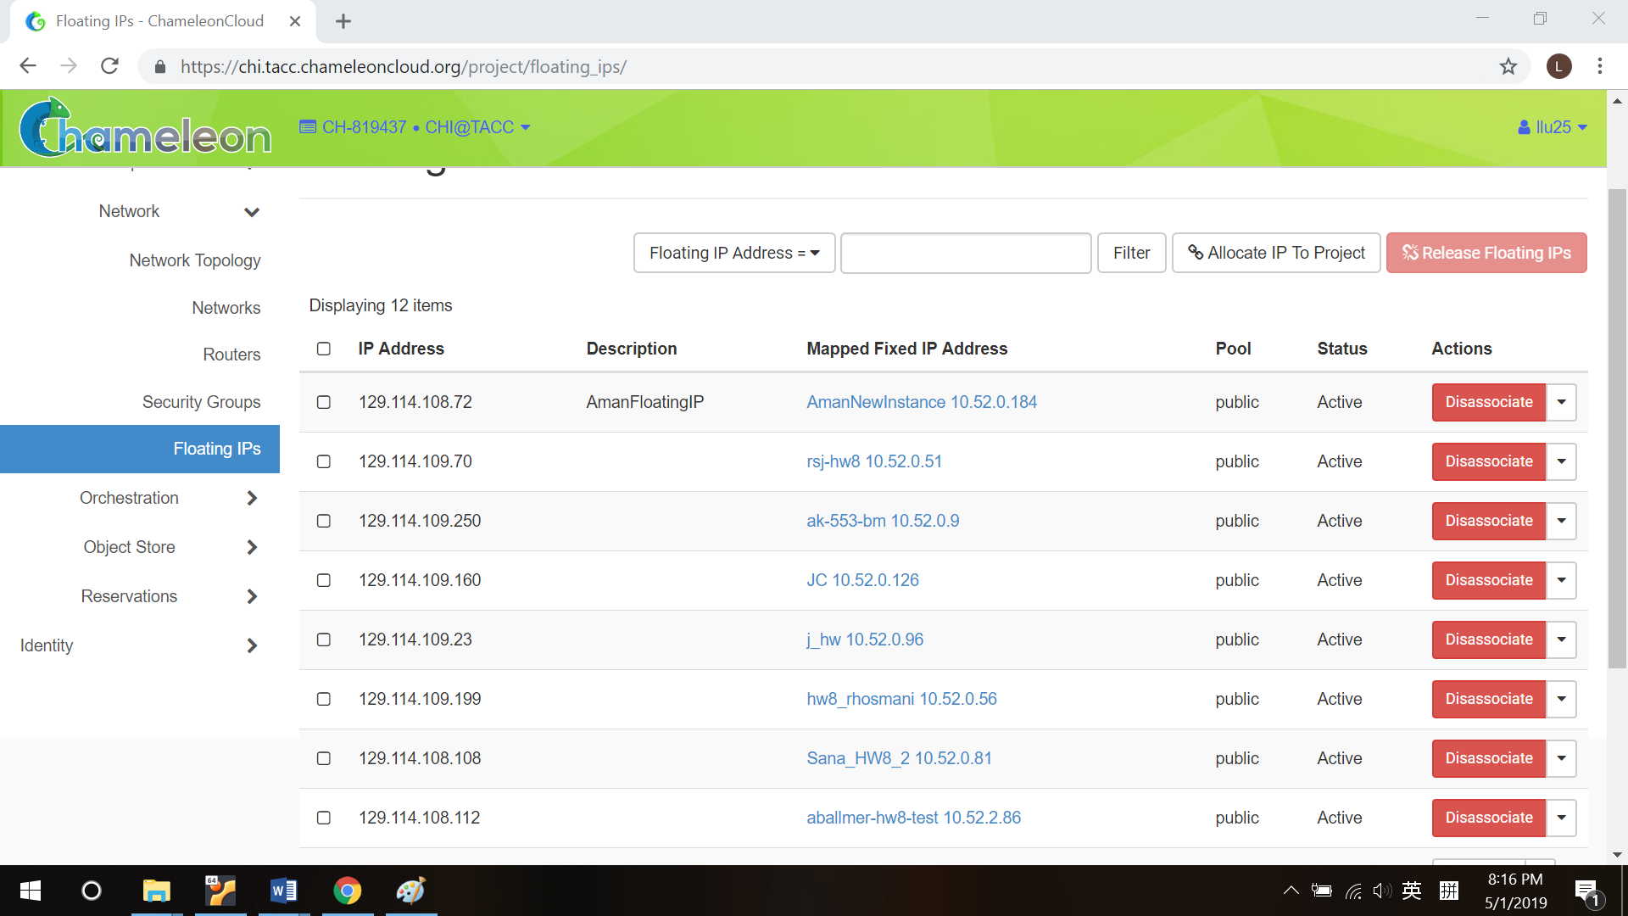

(i) After above configuration, you will successfully create an instance with an IP address.

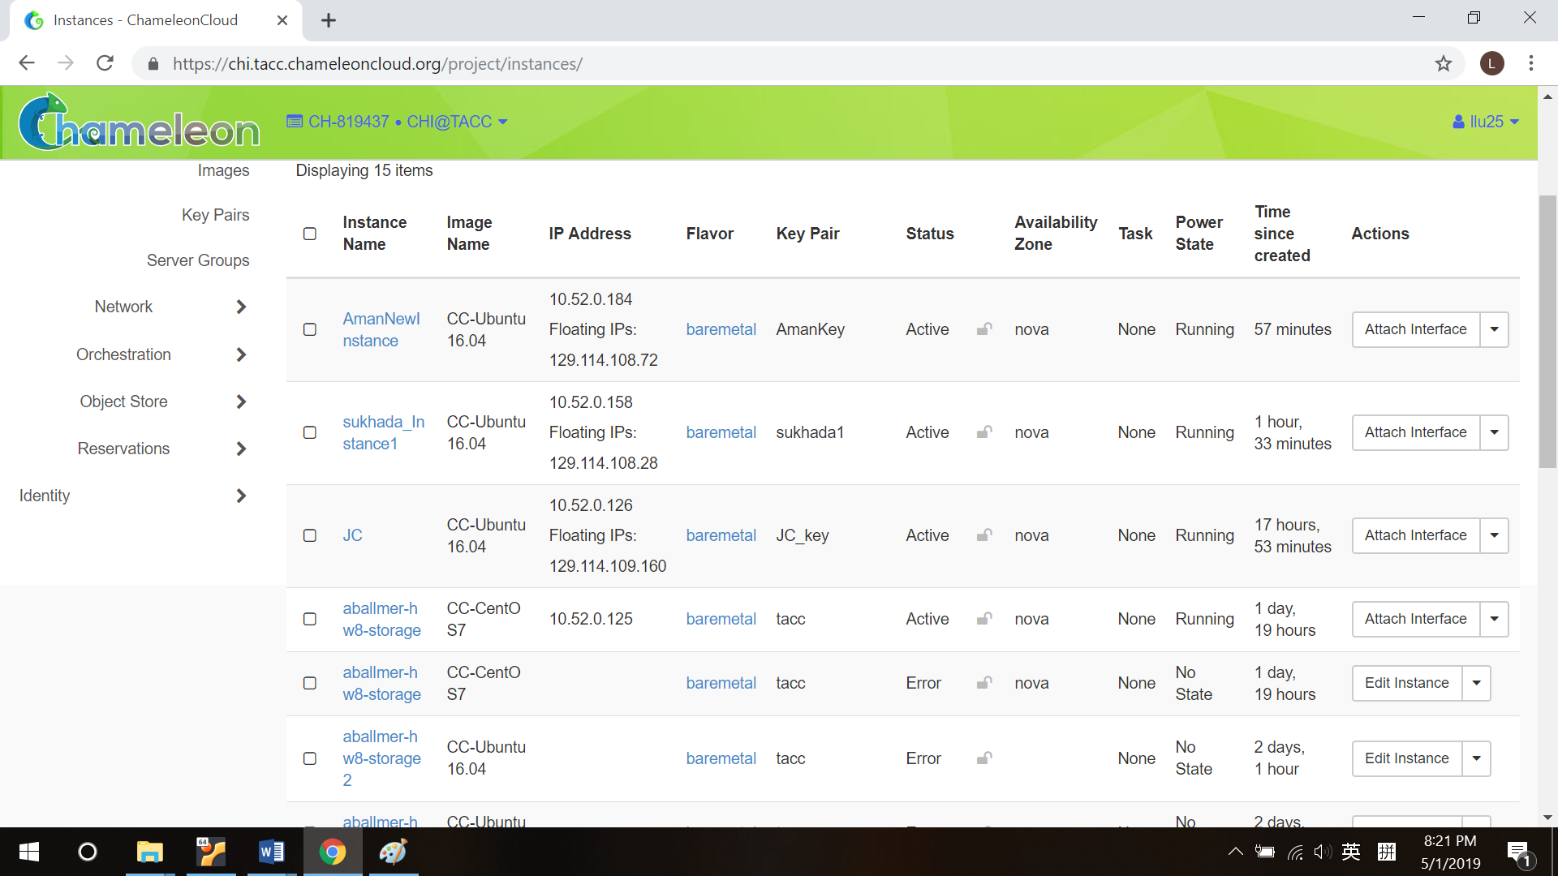

**2: SSH to your server**

(a) Before copying your public key to server, you must generate it. Use “ssh-keygen” command to generate a key pair. If you didn’t change default path, the key pair should in ~/.ssh directory.

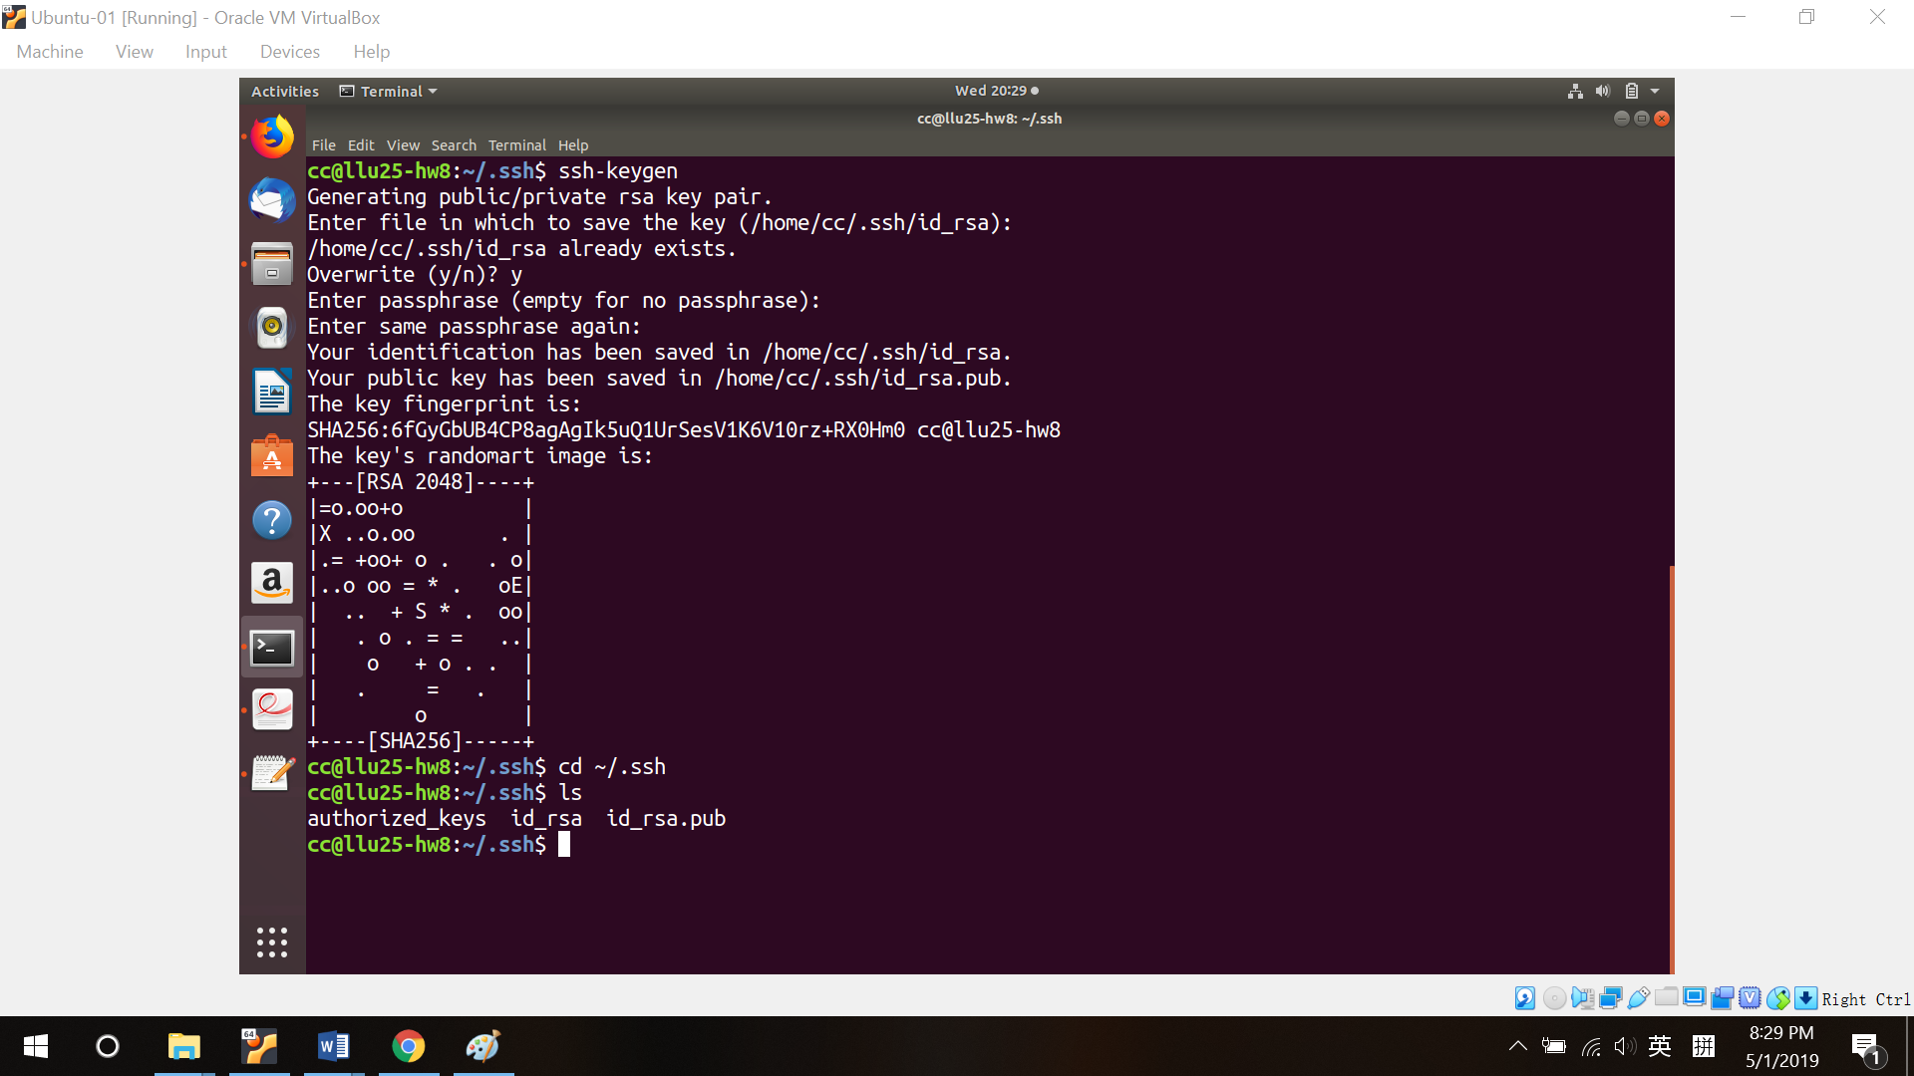

(b) You can copy your public key to a remote server by using “ssh-copy-id user_name@server_ip”.

**3: Create and instance via lxc**

(a) First install lxc if your system doesn’t have. Then do some basic configurations like install a software to manage your file, set up disk capacity, set up bridged network, user permission and so on. All of them can be found on this website: *https://tutorials.ubuntu.com/tutorial/tutorial-setting-up-lxd-1604#0*. Then create your name node and server data nodes. In order to allow nfs services, you must tell your appaarmor that such services is legal. Without such setting, you cannot use nfs. This is the most critical part!! We spend several days to figure it out. The solution sounds simple, just add ‘fstype=nfs”, but it’s very very very critical!!!!

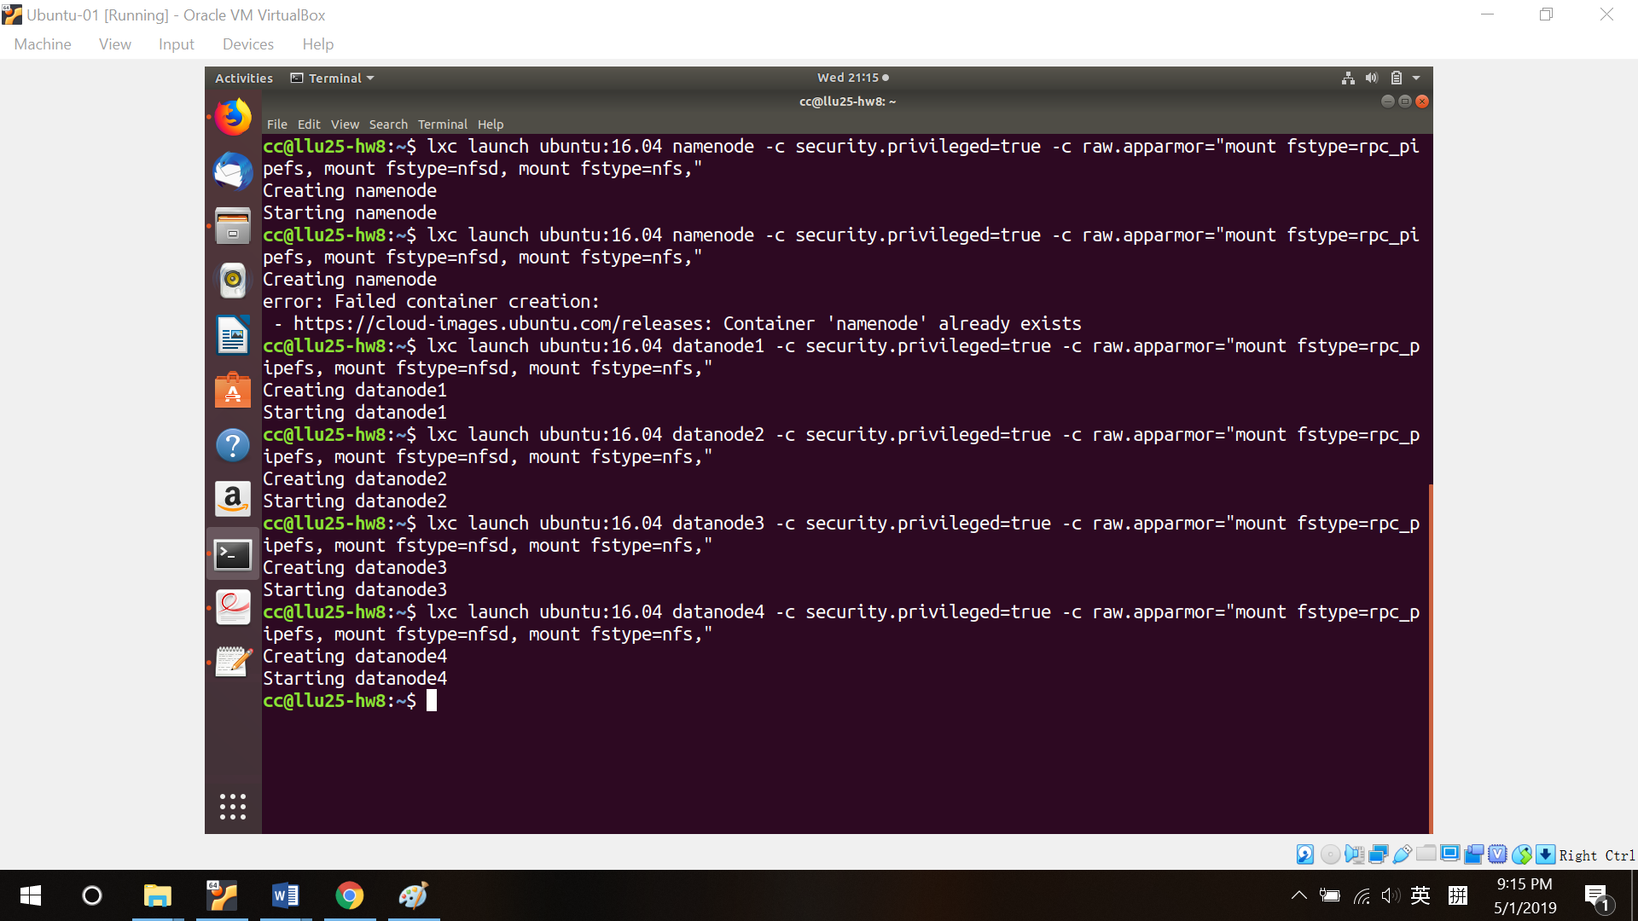

(b) You can limit cpu number and memory space.

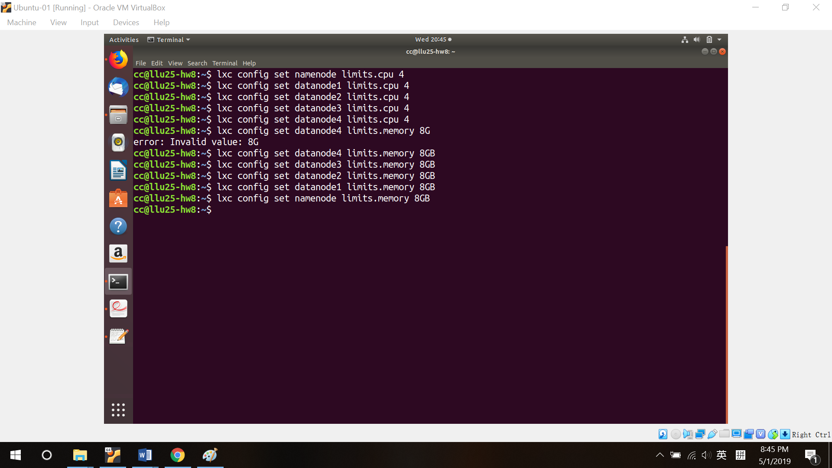

(c) Enter your virtual machine.

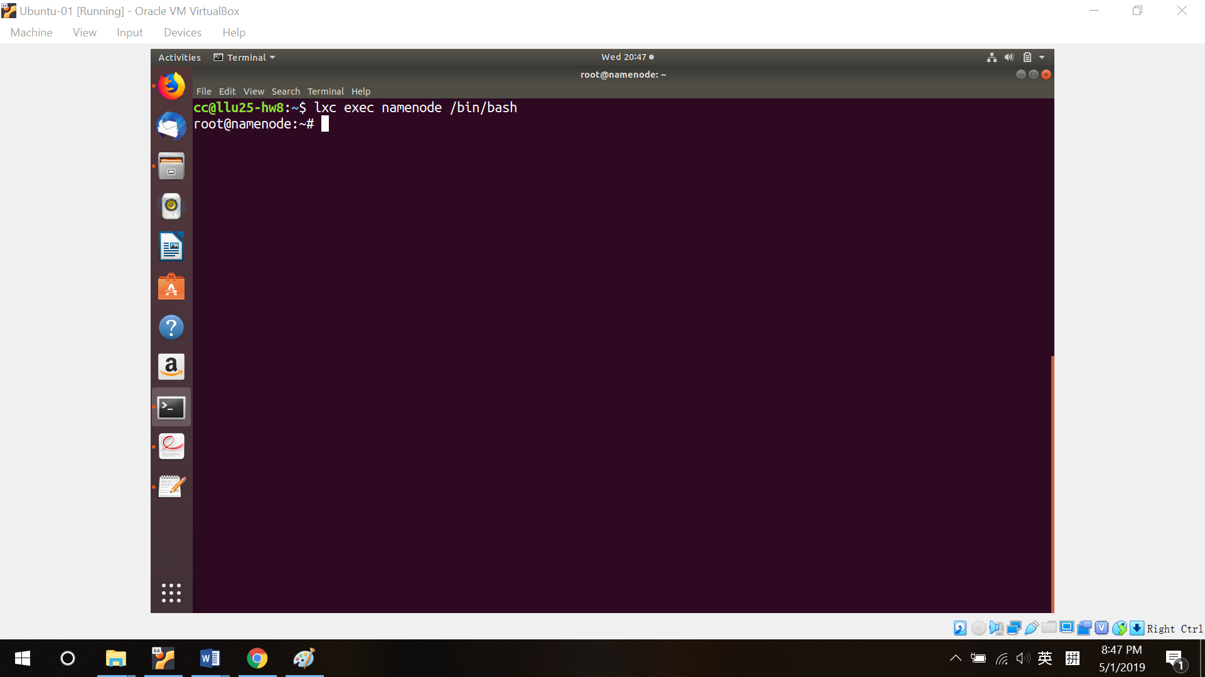

**4: Add sudo user, install java and set up ssh.**

(a) I don’t want to do everything with root permission. So I create sudo users.

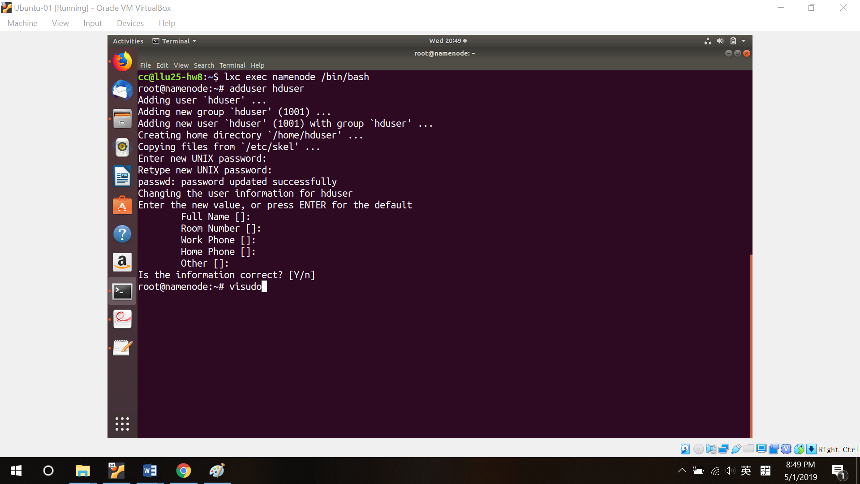

(b) Go into visudo to give the new created user sudo permission.

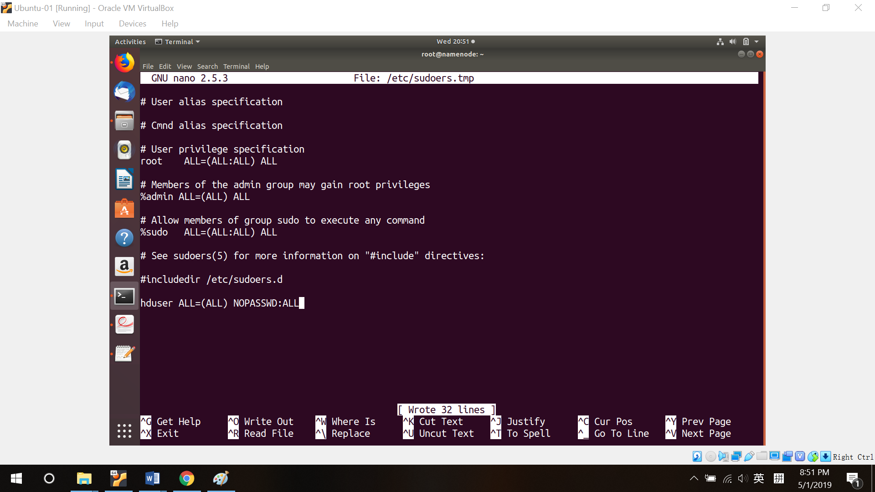

(c) lxc set password authorization to “no” by default. To use ssh, set it to “yes”.

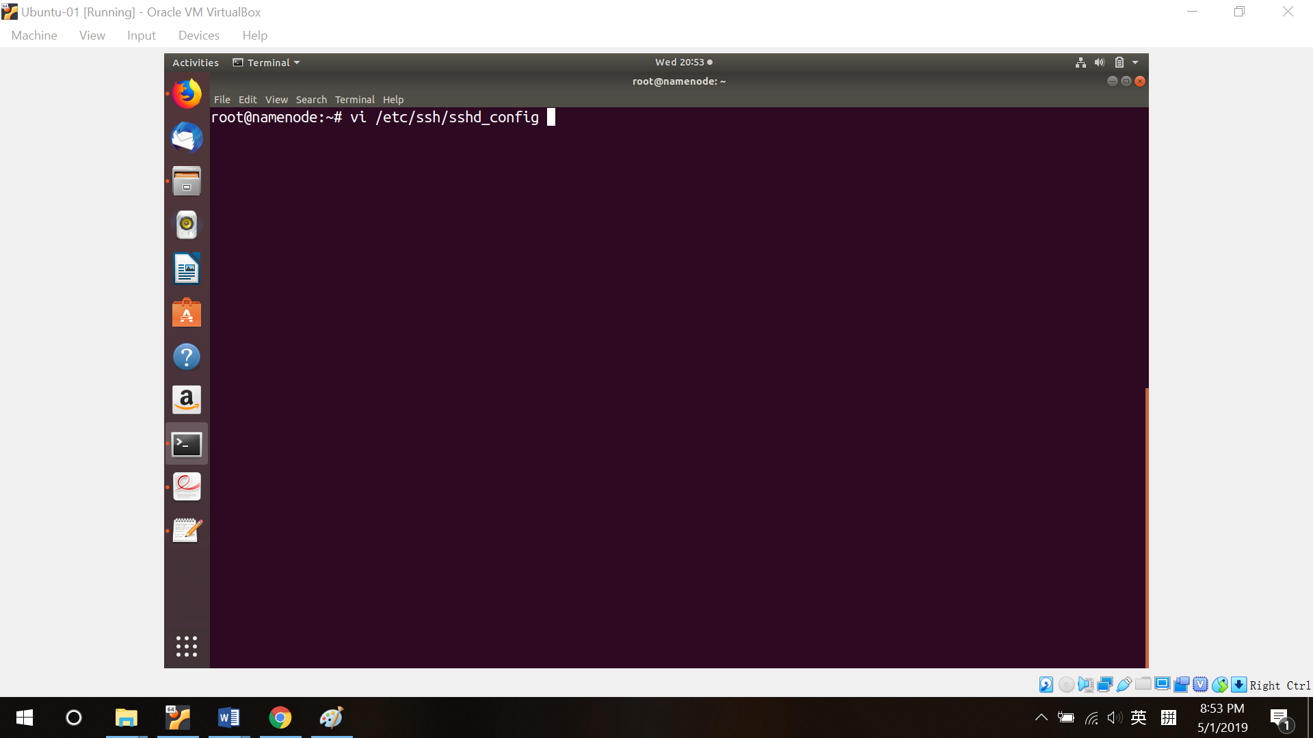

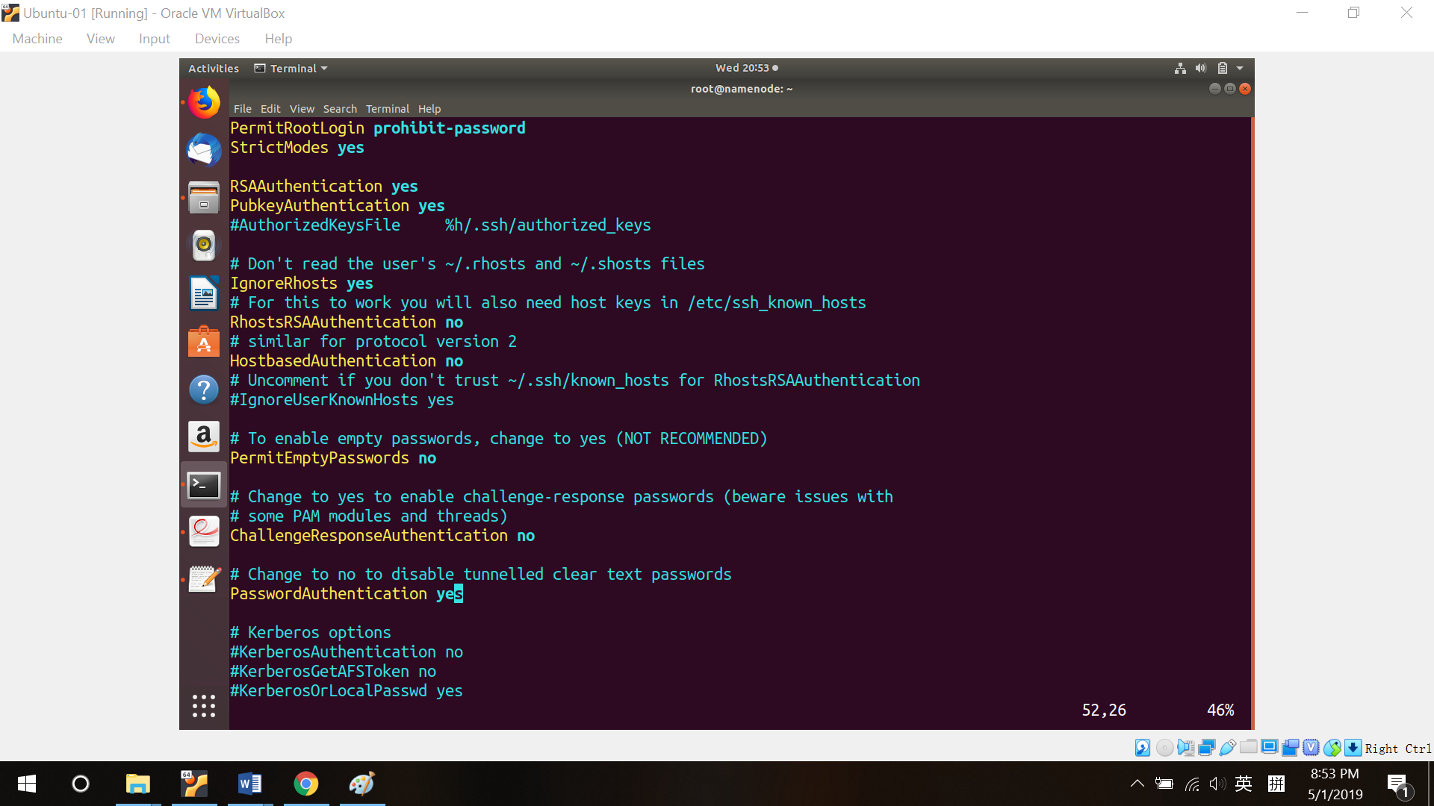

(d) Don’t forget to restart ssh to active your setting.

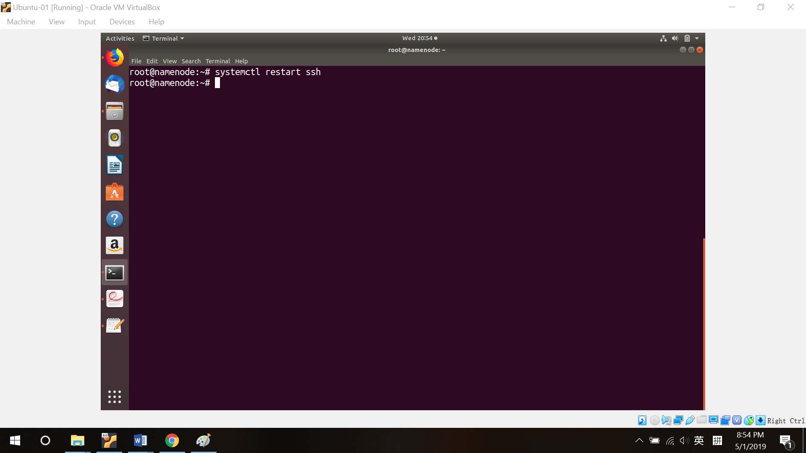

(e) Do step (a) to (d) on all nodes to allow ssh.

(f) Check all your nodes’ IP addresses. Save them in a file. We will paste it into all nodes’ host file. So we don’t have to enter IP address every time.

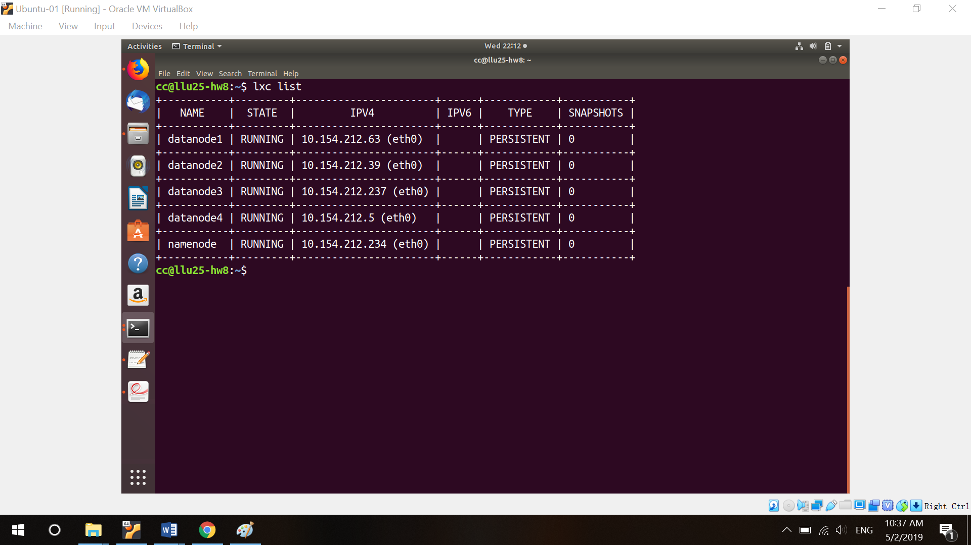

(g) Open your name node, update and upgrade your system (all nodes), generate a key pair (all nodes), overwrite host file (all nodes) and copy your public key to other nodes (name node must copy its key to all nodes which includes itself; data node only needs to send their pubic key to name node).

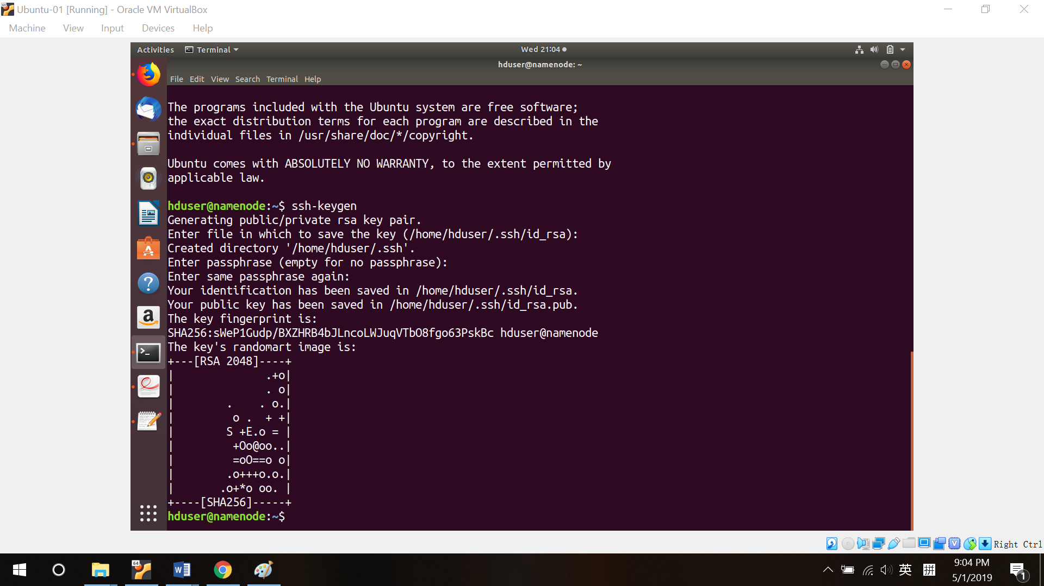

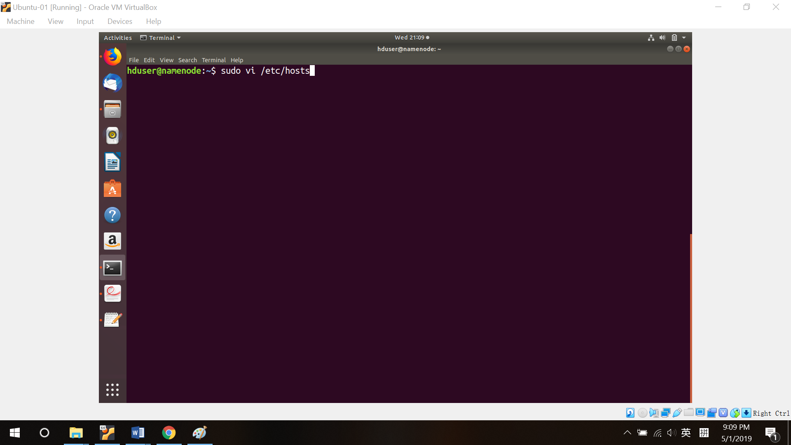

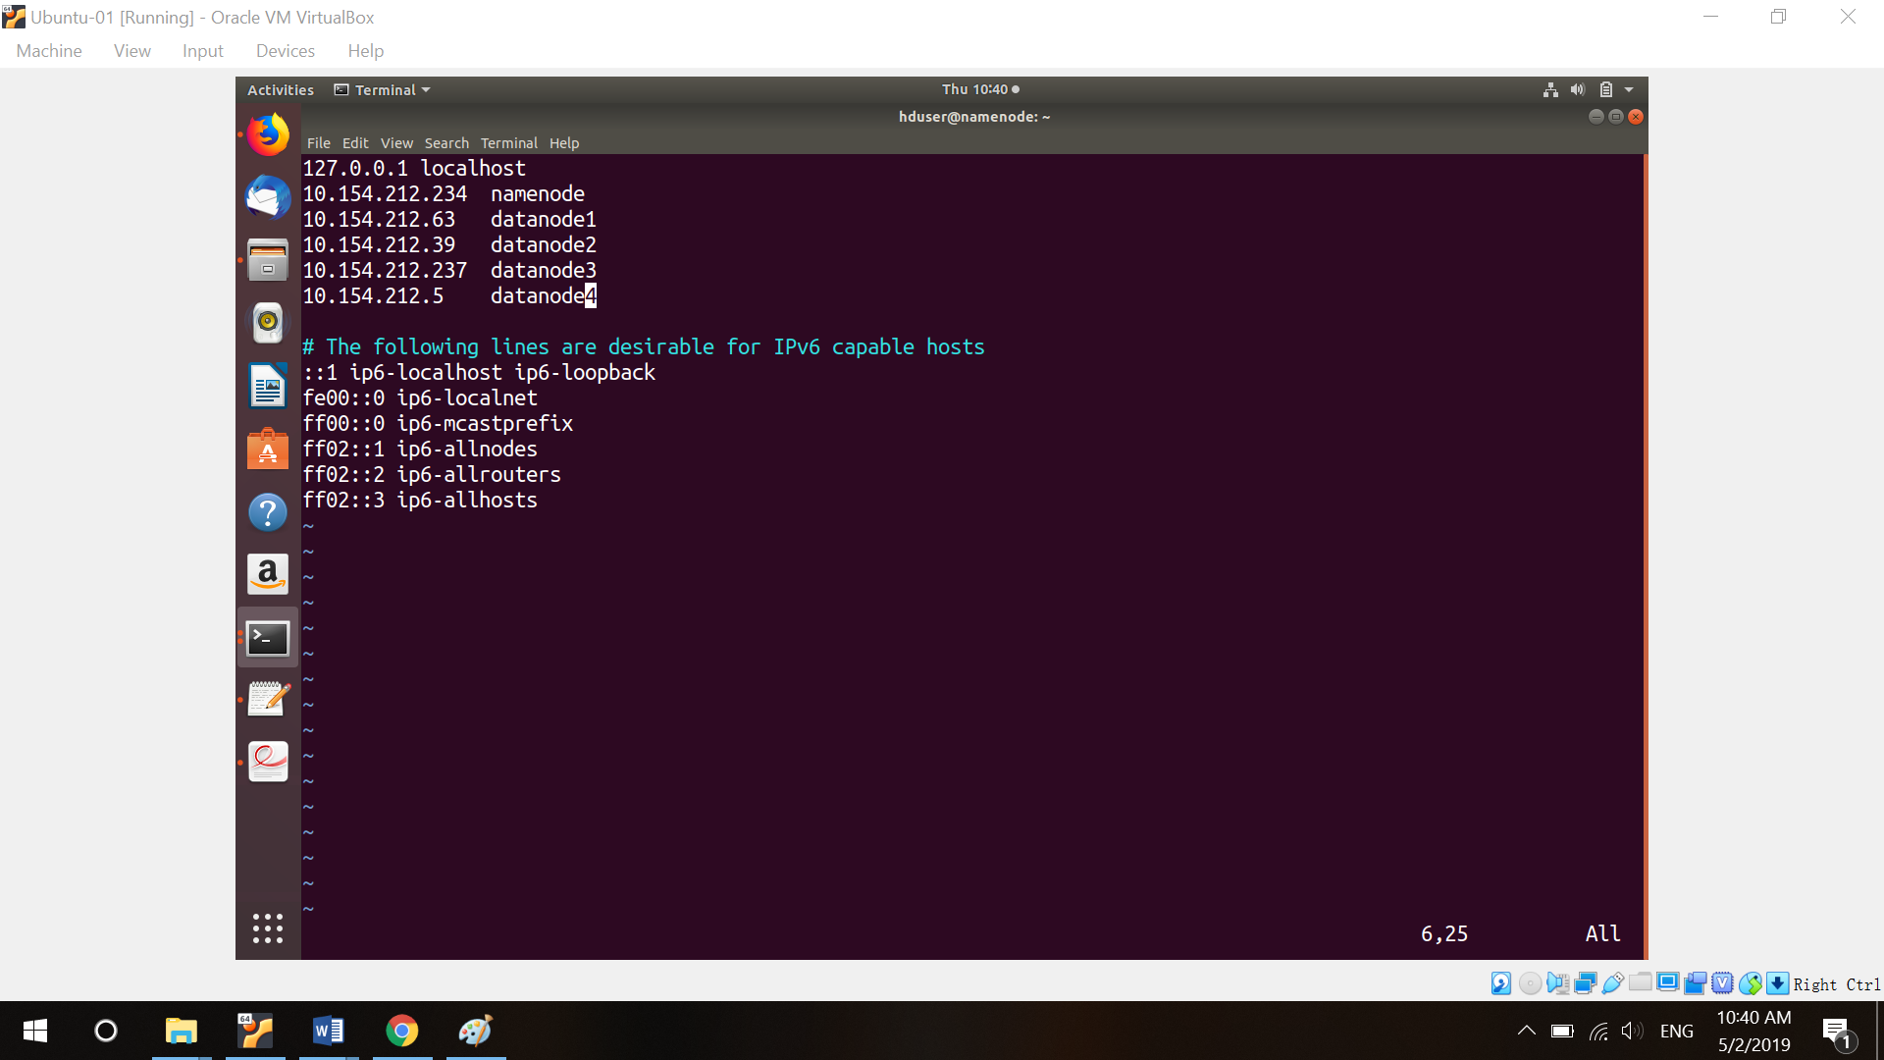

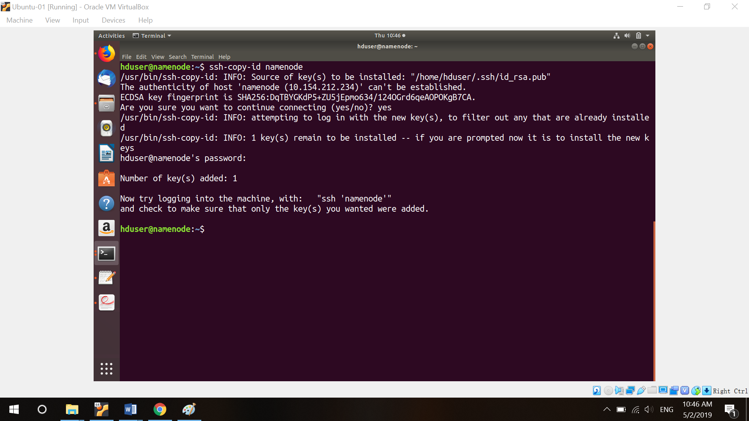

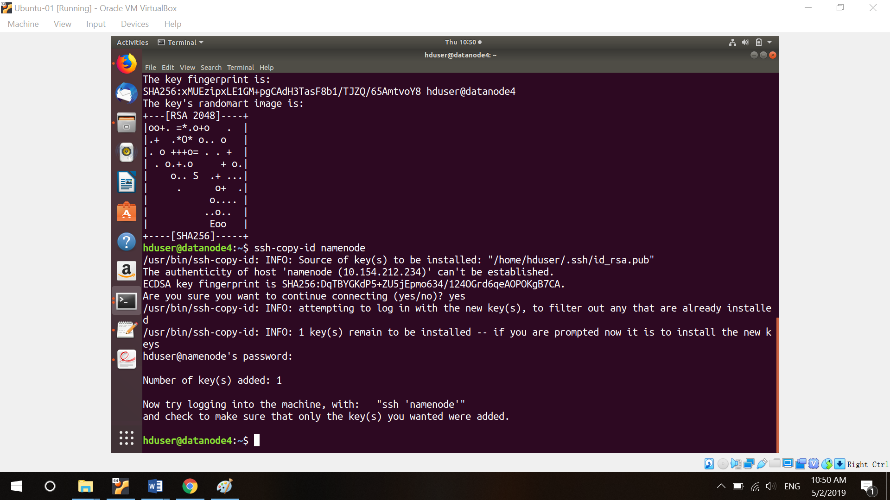

(f) Install java and set up JAVA_HOME on all nodes.

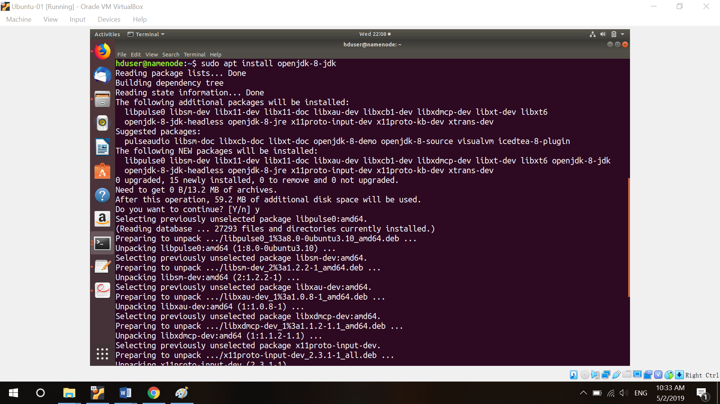

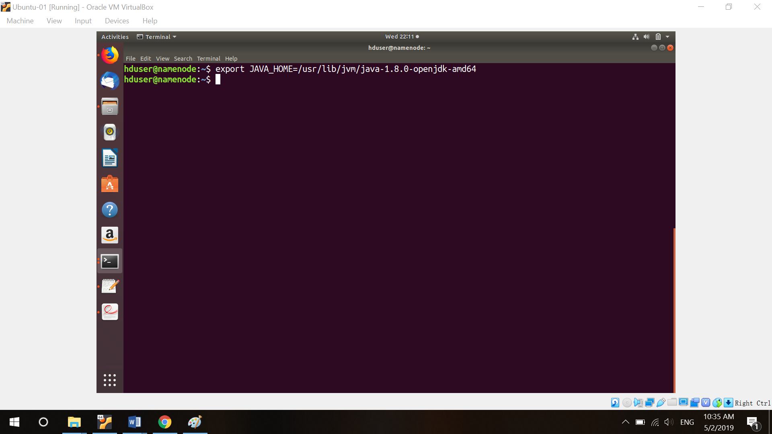

**5. NFS**

(a) Install nfs server on your name node. And open idmapd.conf and uncomment line 6.

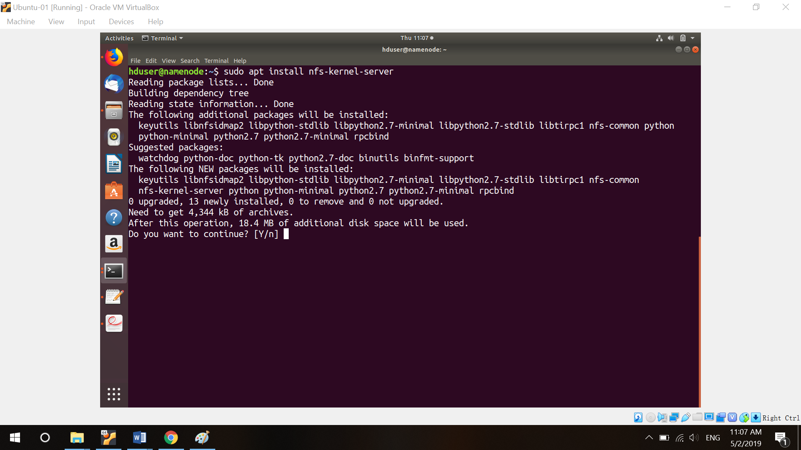

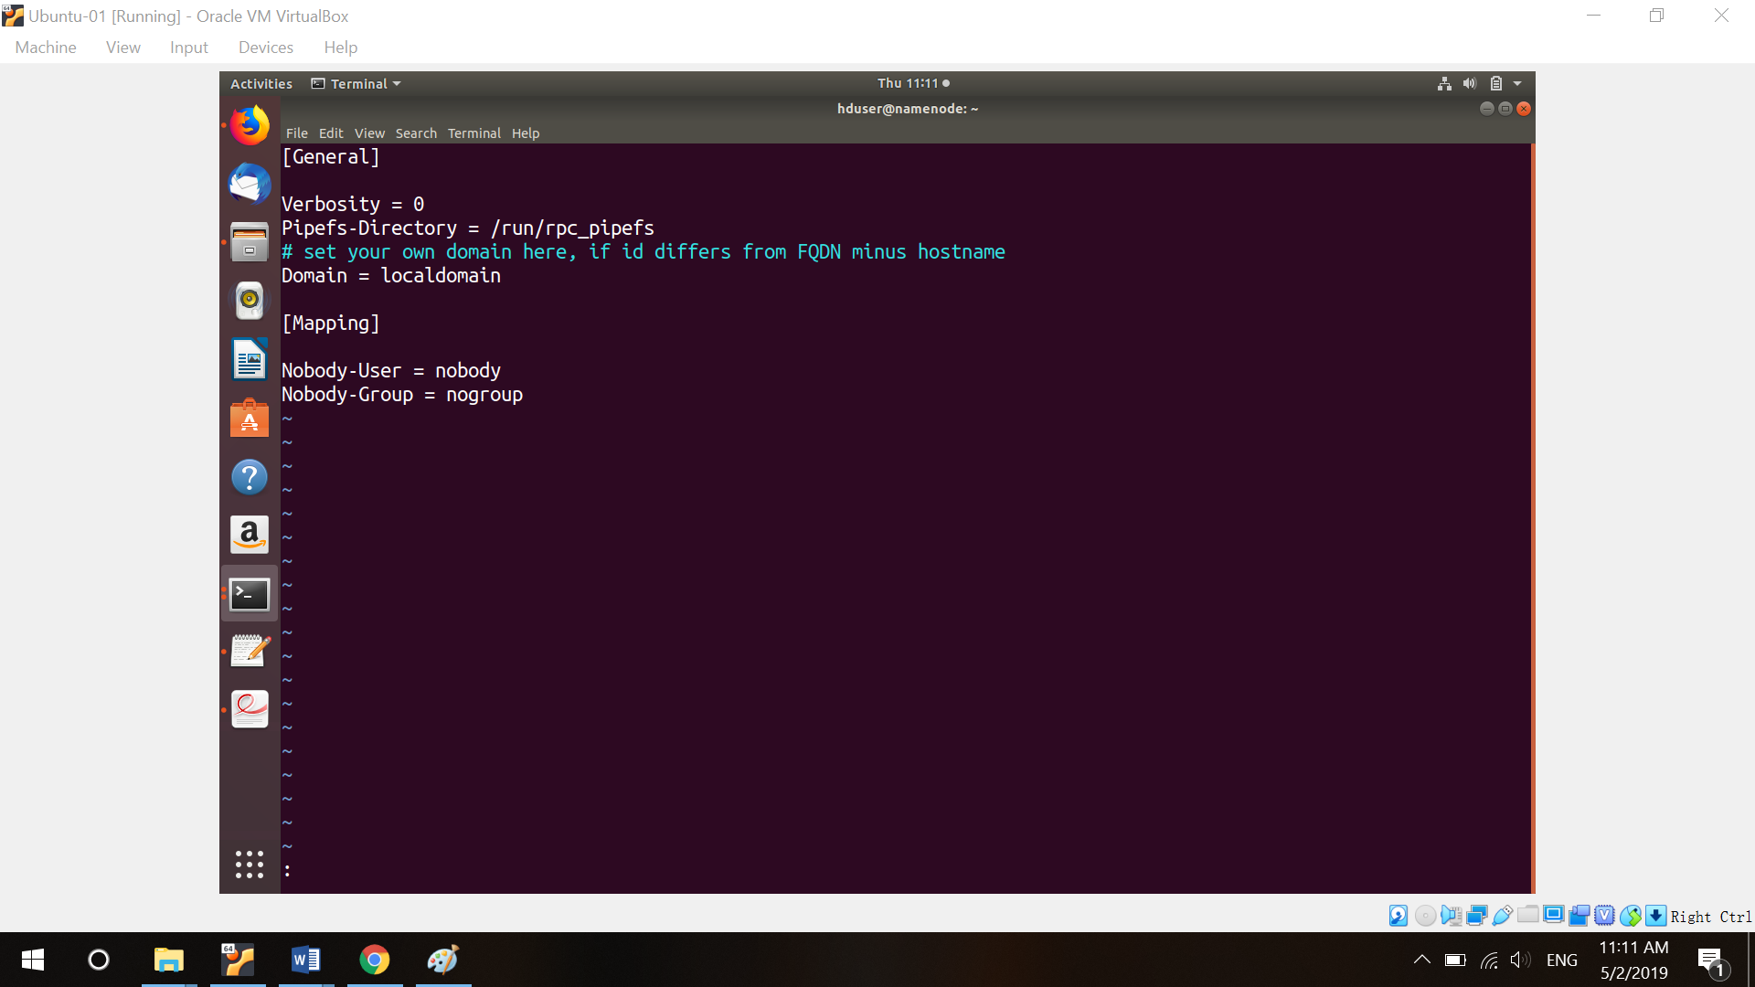

(b) Create a directory for nfs and give permission to current user.

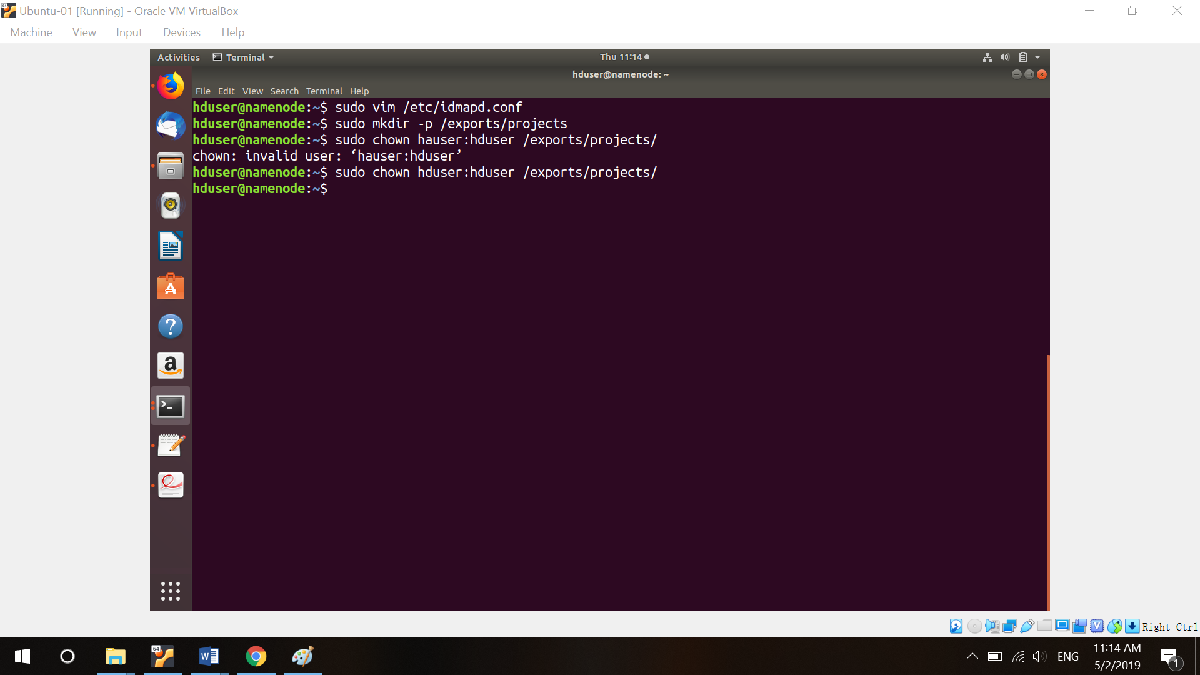

(c) Open “sudo vim /etc/exports” and change like this. IP address is your name node’s IP address. (24 means maximize network permission). This command allows 10.154.212.ALL to mount the file.

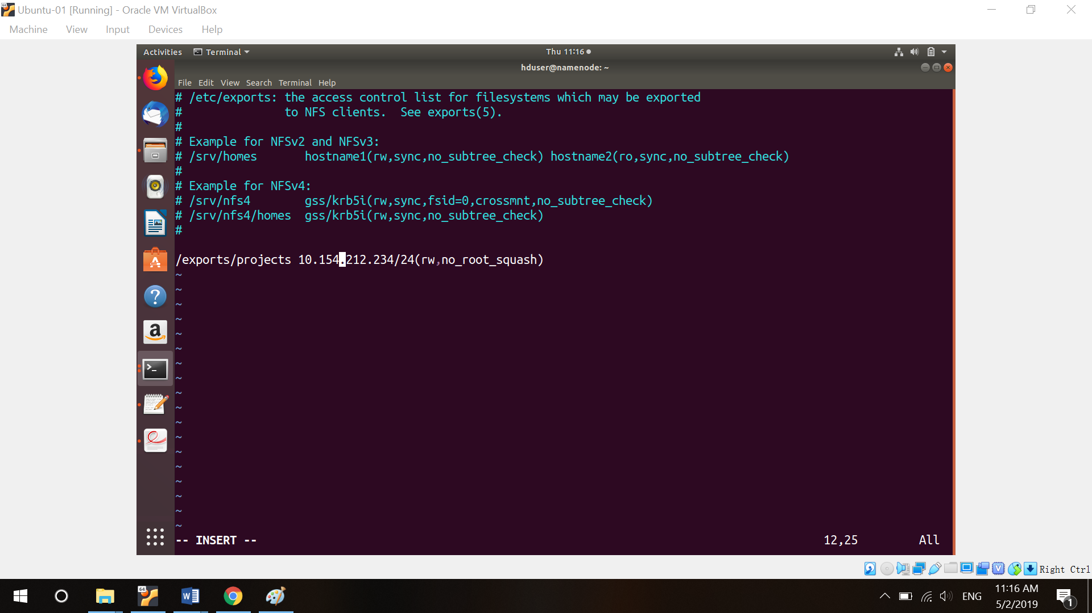

(d) Restart your nfs server and see its current status. It should look like this.

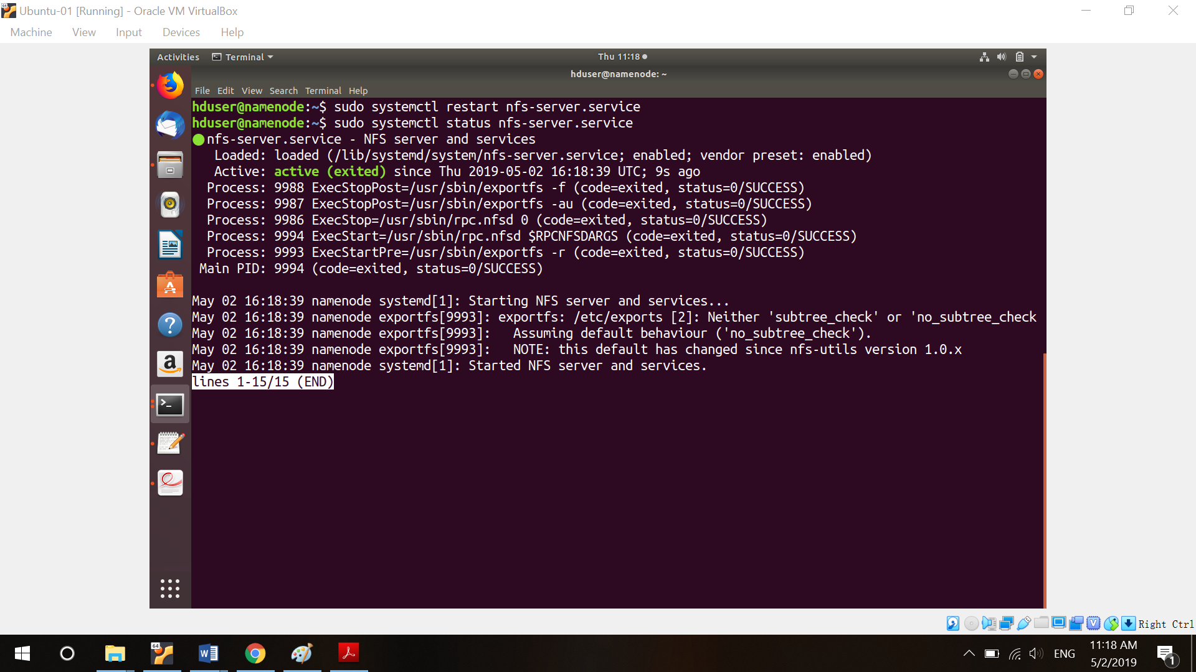

(c) Go to your data nodes, download nfs client, change idmapd.conf, create a new directory (/exports/projects, name must totally equal to name node directory), and give current user permission.

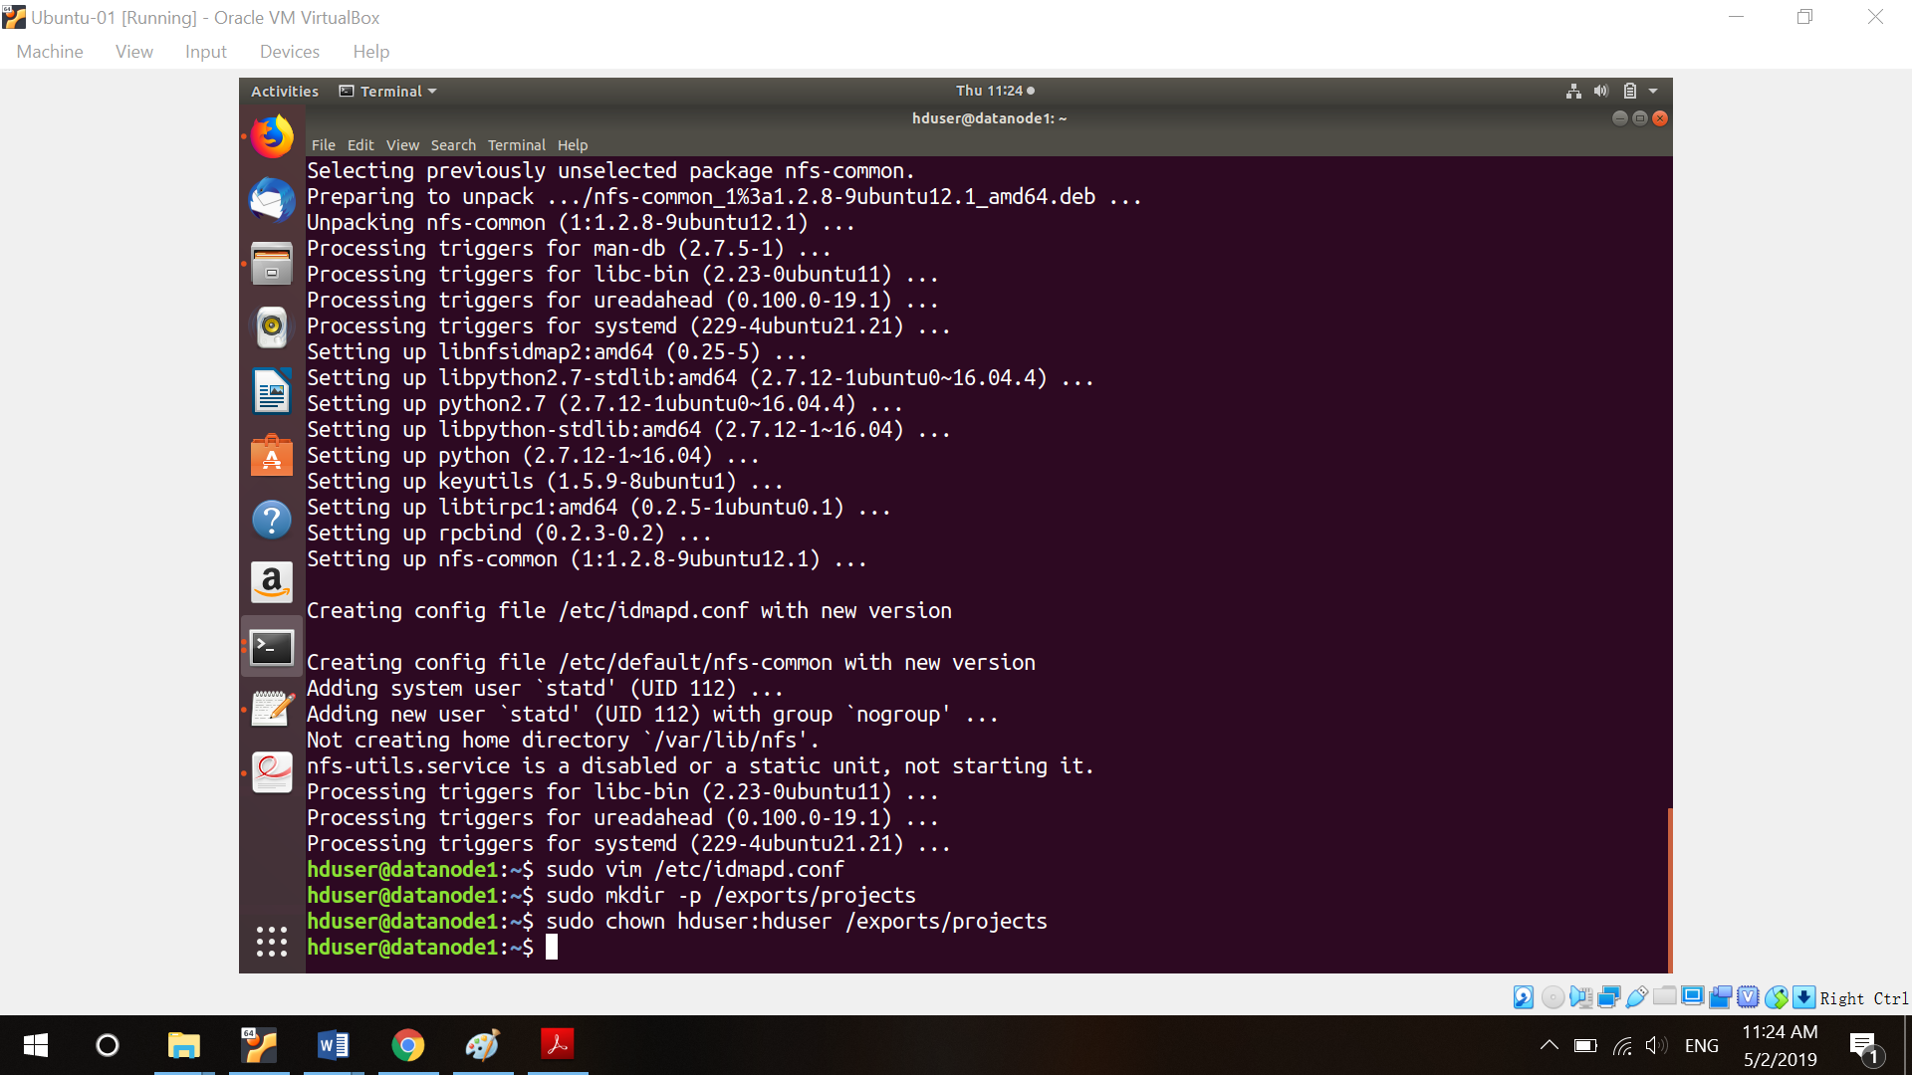

(d) Open “sudo vim /etc/fstab” and modify the like this.

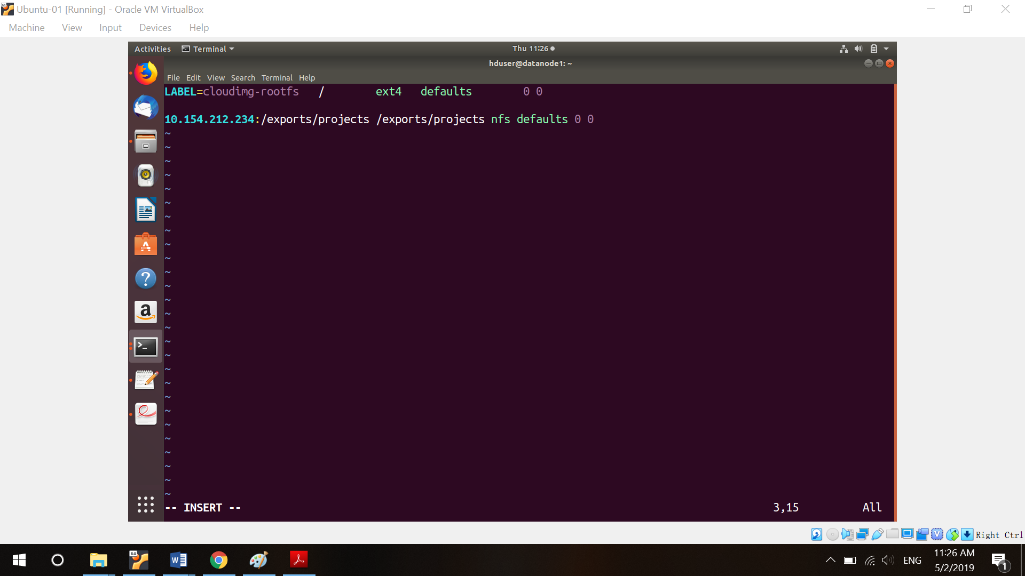

(e) Mount the file and see status, you will see this.

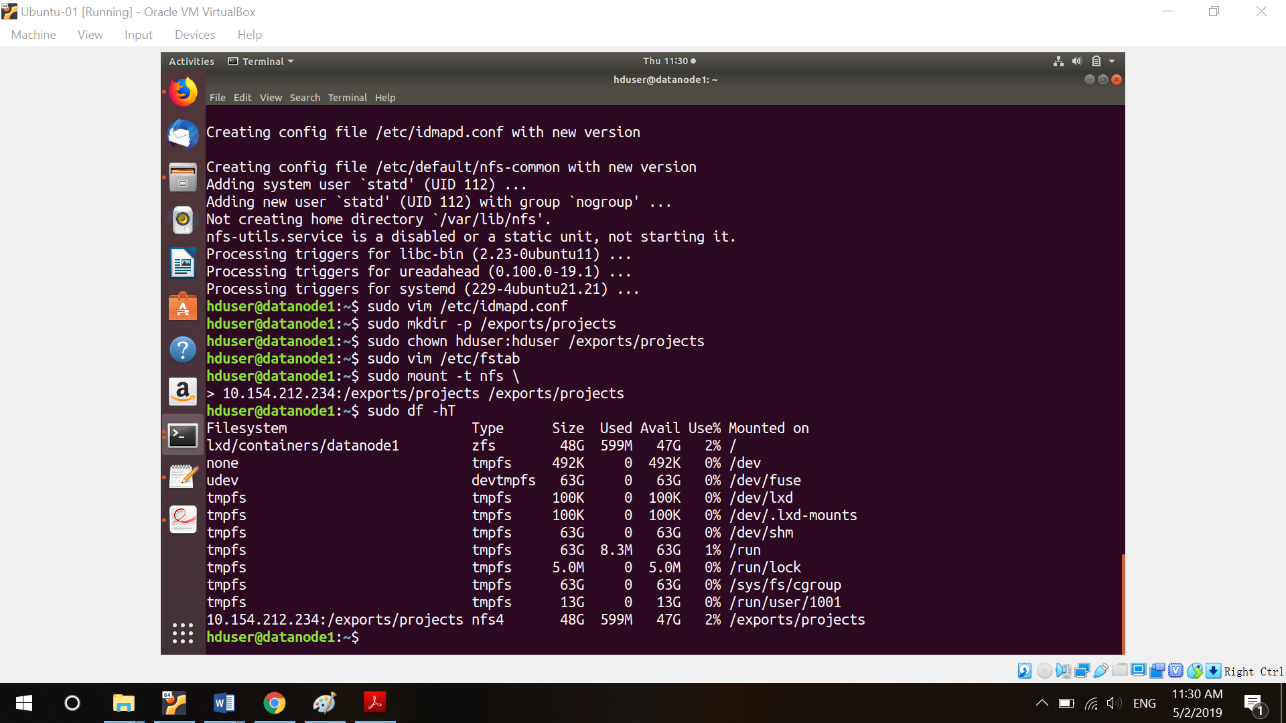

(f) Do such thing on all data nodes.

**5. Hadoop**

(a) Download Hadoop to your system (name node).

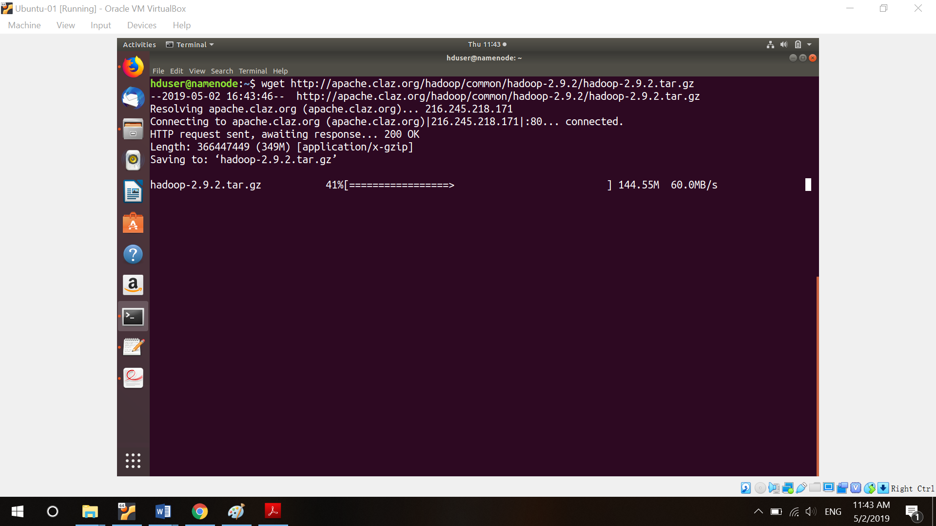

(b) Run such commands “cp hadoop-2.9.2.tar.gz /exports/projects/.”, “cd /exports/projects”, “cd /exports/projects”, “tar xvf hadoop-2.9.2.tar.gz”. Hadoop will be uncompressed.

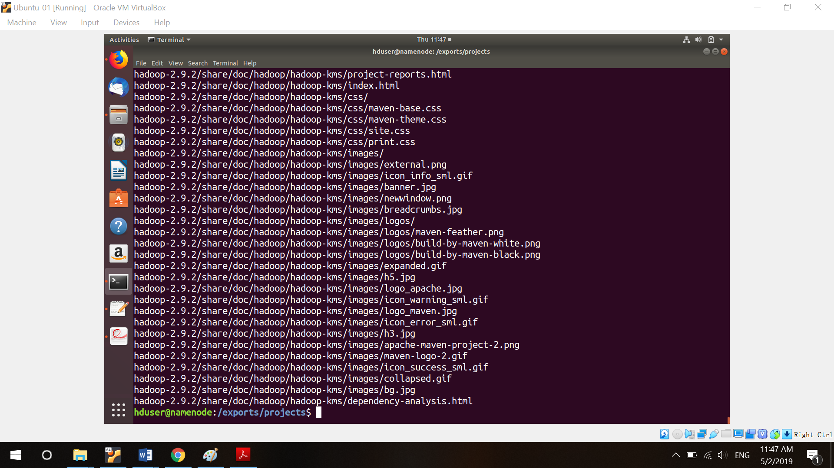

(c) Hard code your Java path on Hadoop-env.sh.

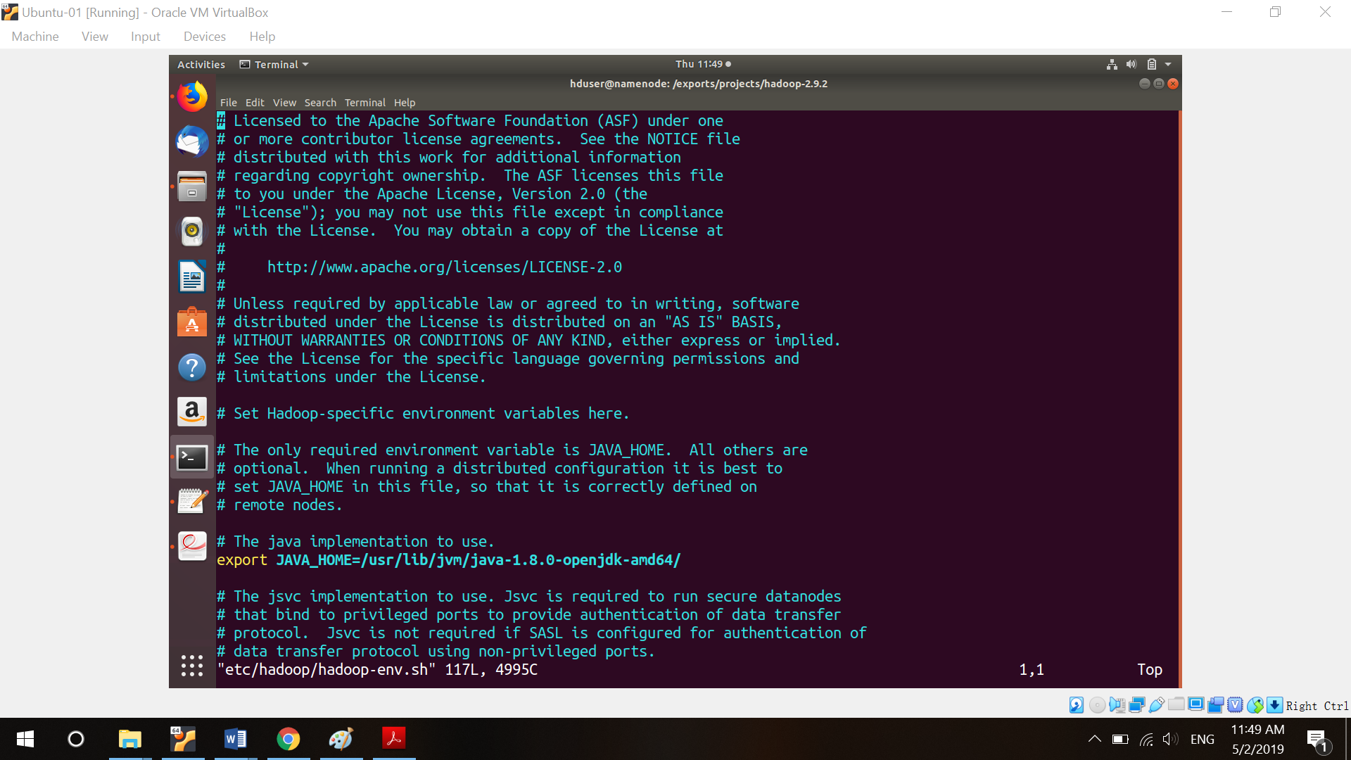

(d) On profiled.d/Hadoop.sh file, so such thing.

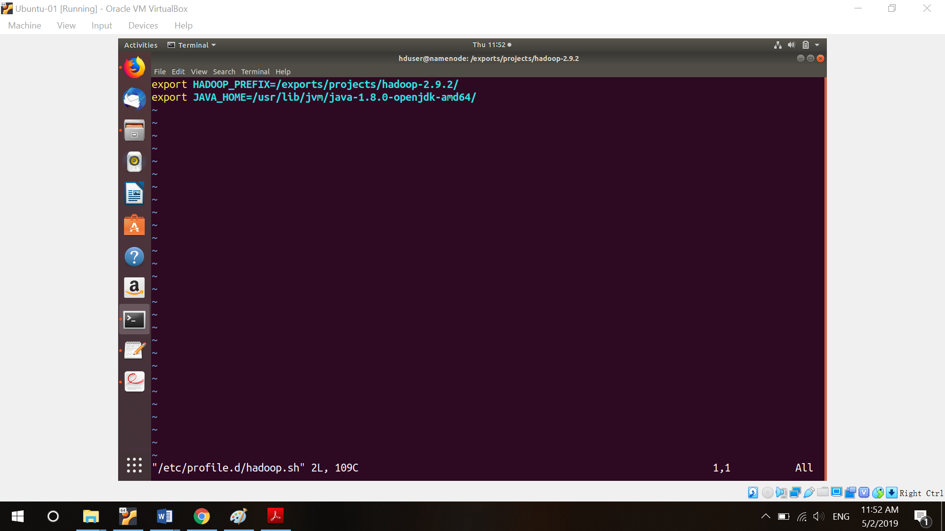

(e) Modify core-site.xml

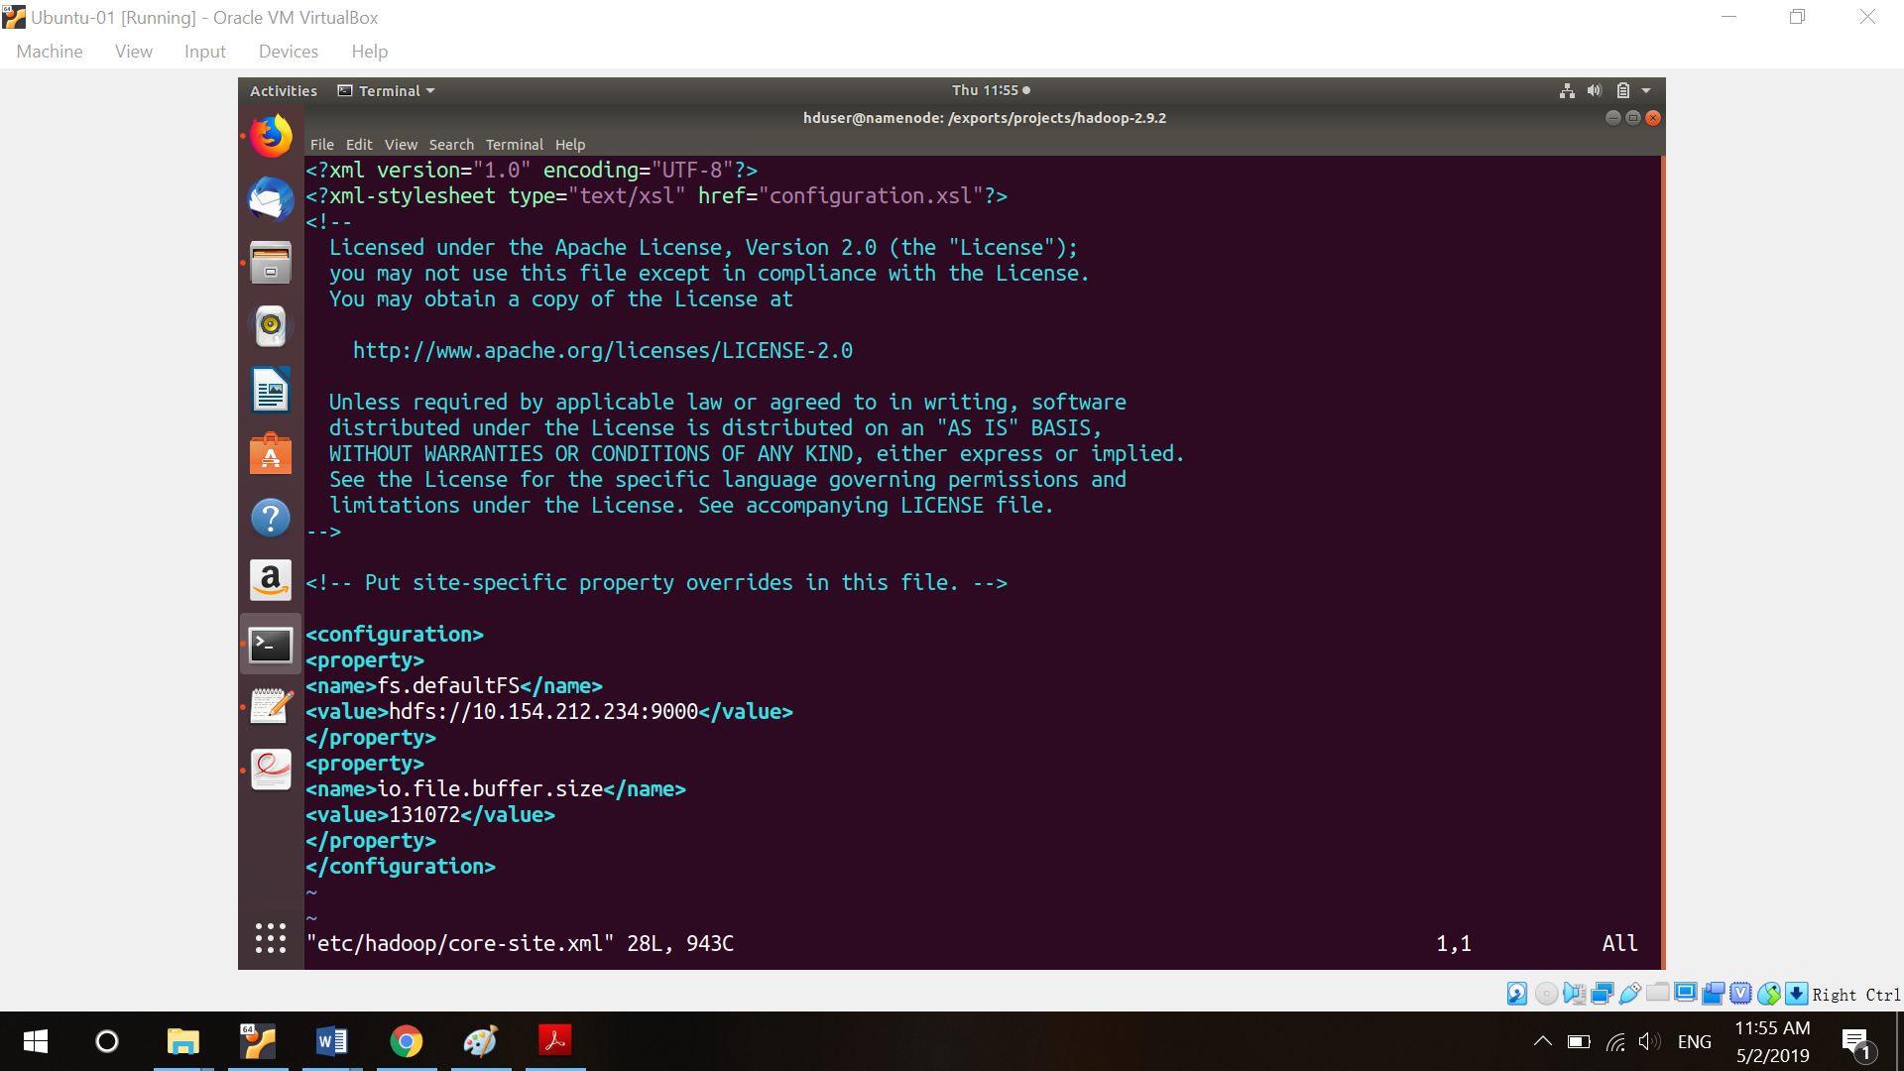

(d) Create a directory on name node to save your metadata. And create a data directory on your data node.

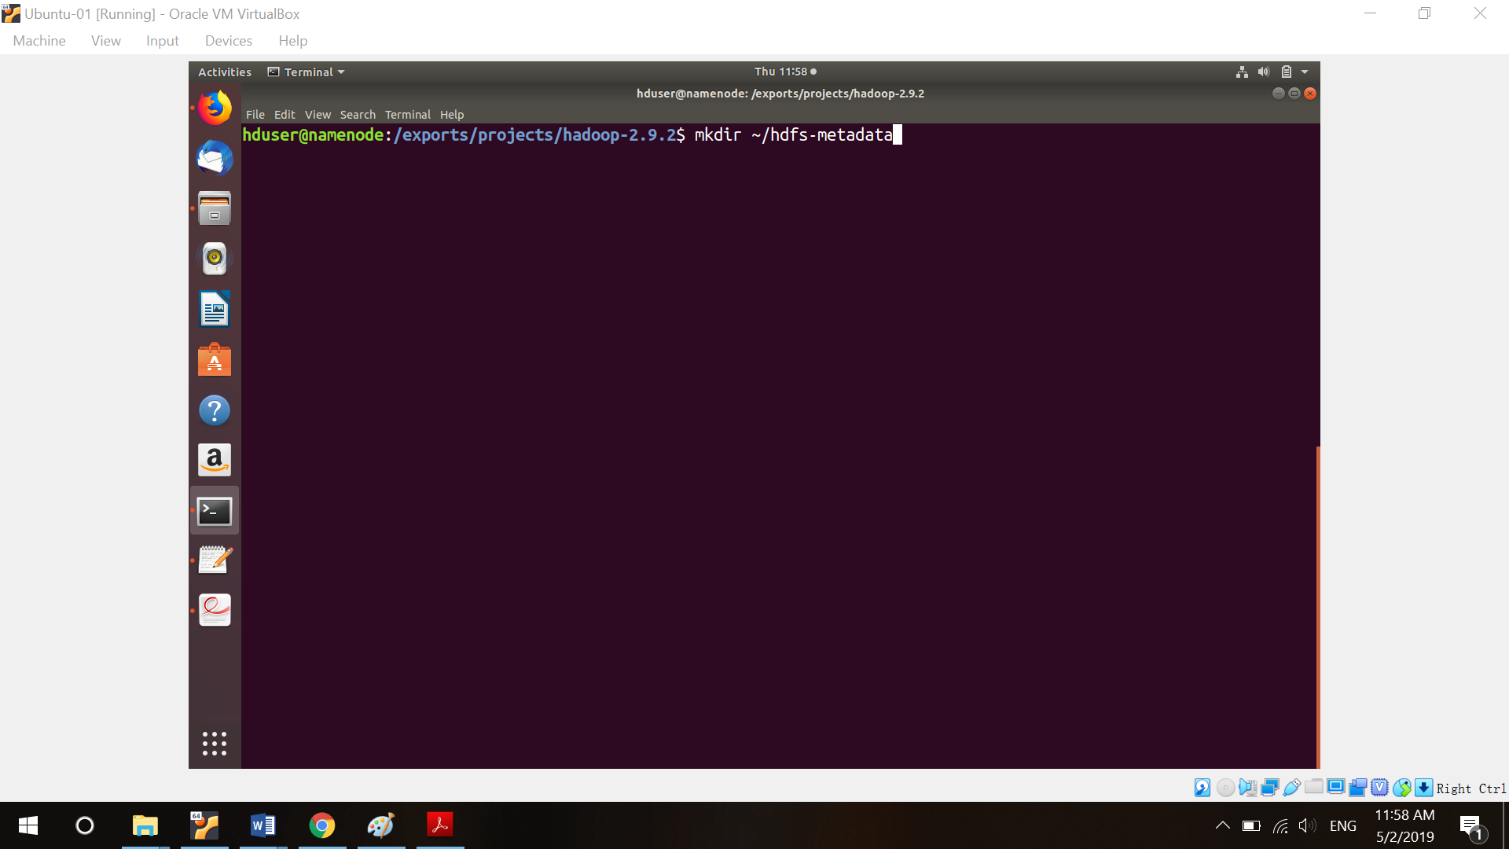

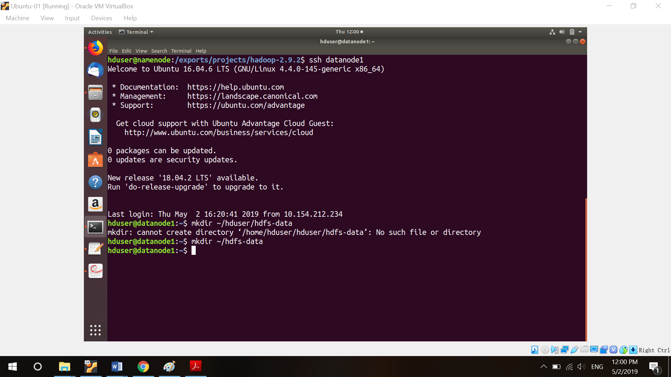

(e) Modify hdfs-site.xml file.

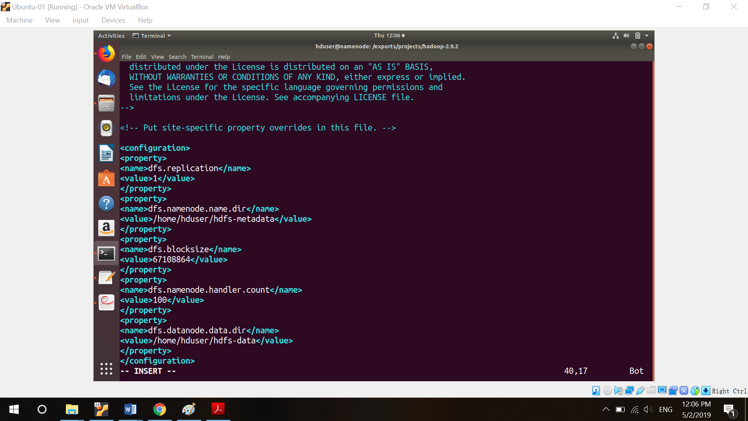

(f) Create log file on all nodes.

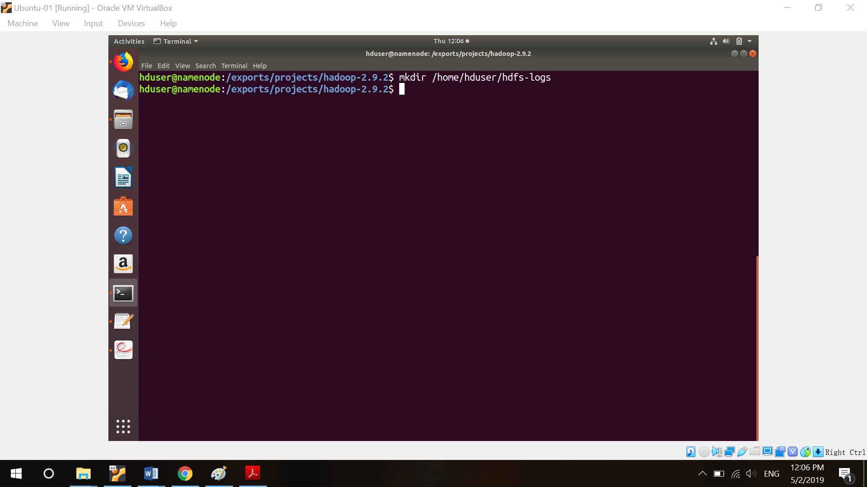

(g) Modify yarn-site.xml.

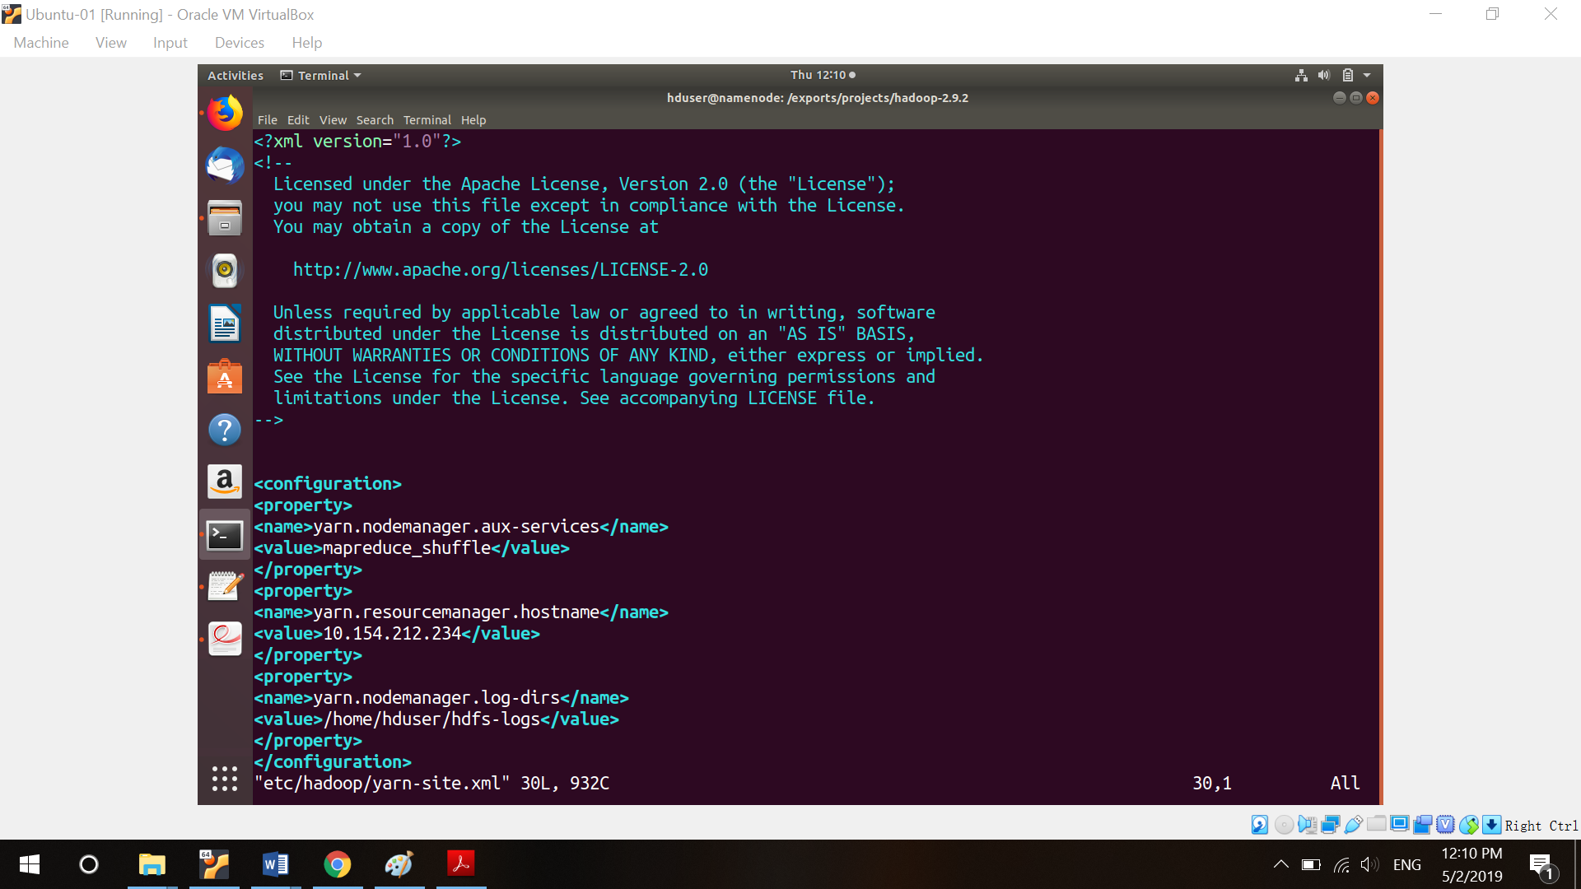

(h) Hadoop higher versions don’t contain mapred-site.xml, we should copy it form mapred-site.xml.template.

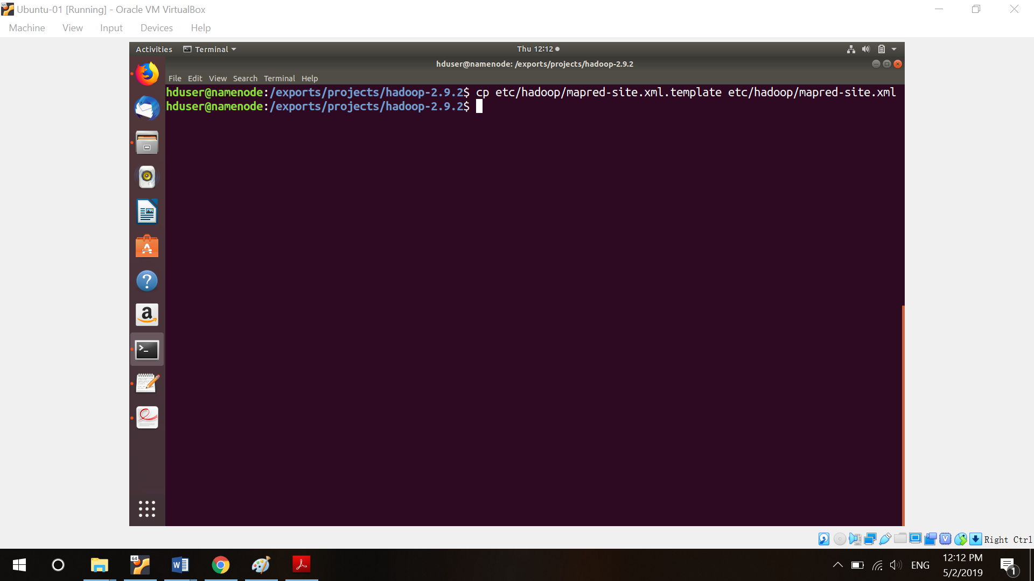

(i) Modify mapred-site.xml. I want to compress the intermediate data because I need to deal with big data.

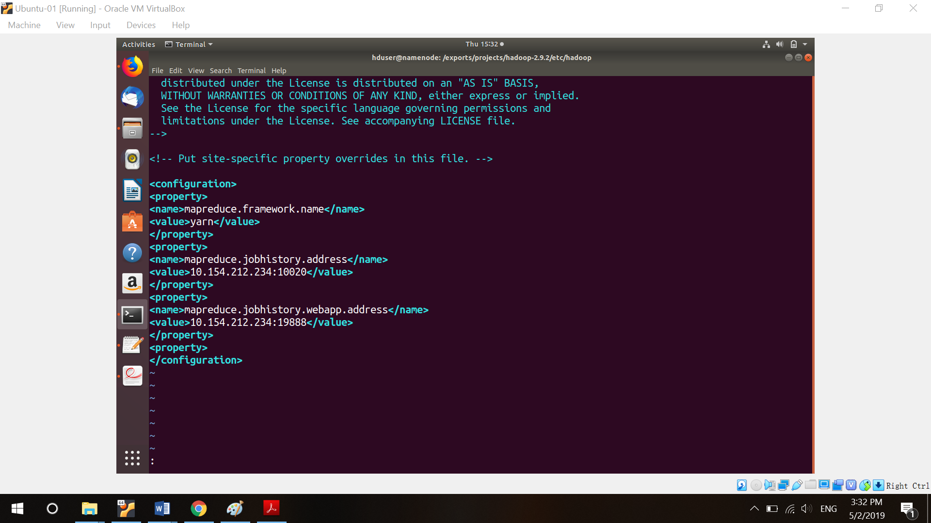

(j) Tell name node who are data nodes.

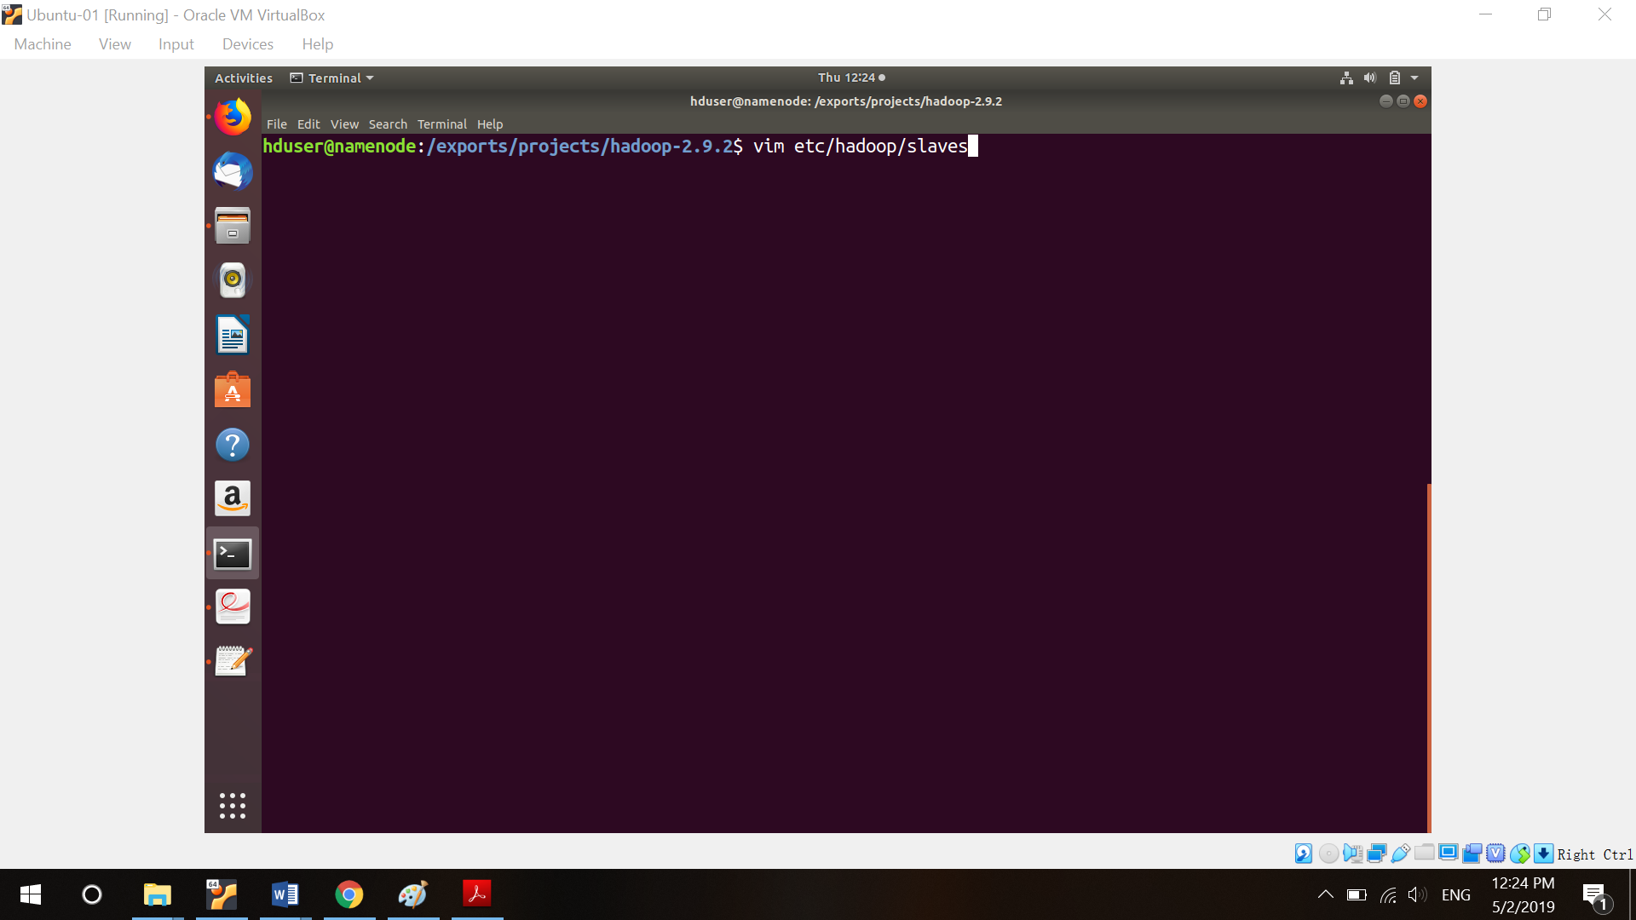

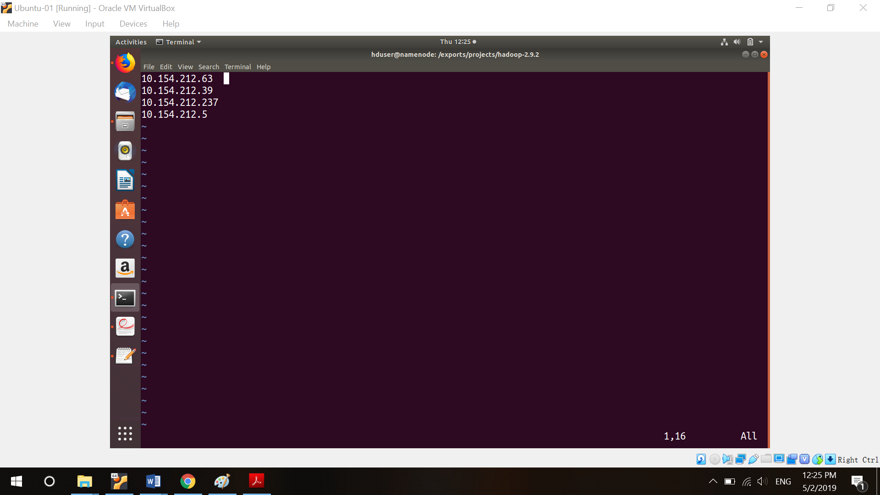

(k) Format and start HDFS, name is hduser.

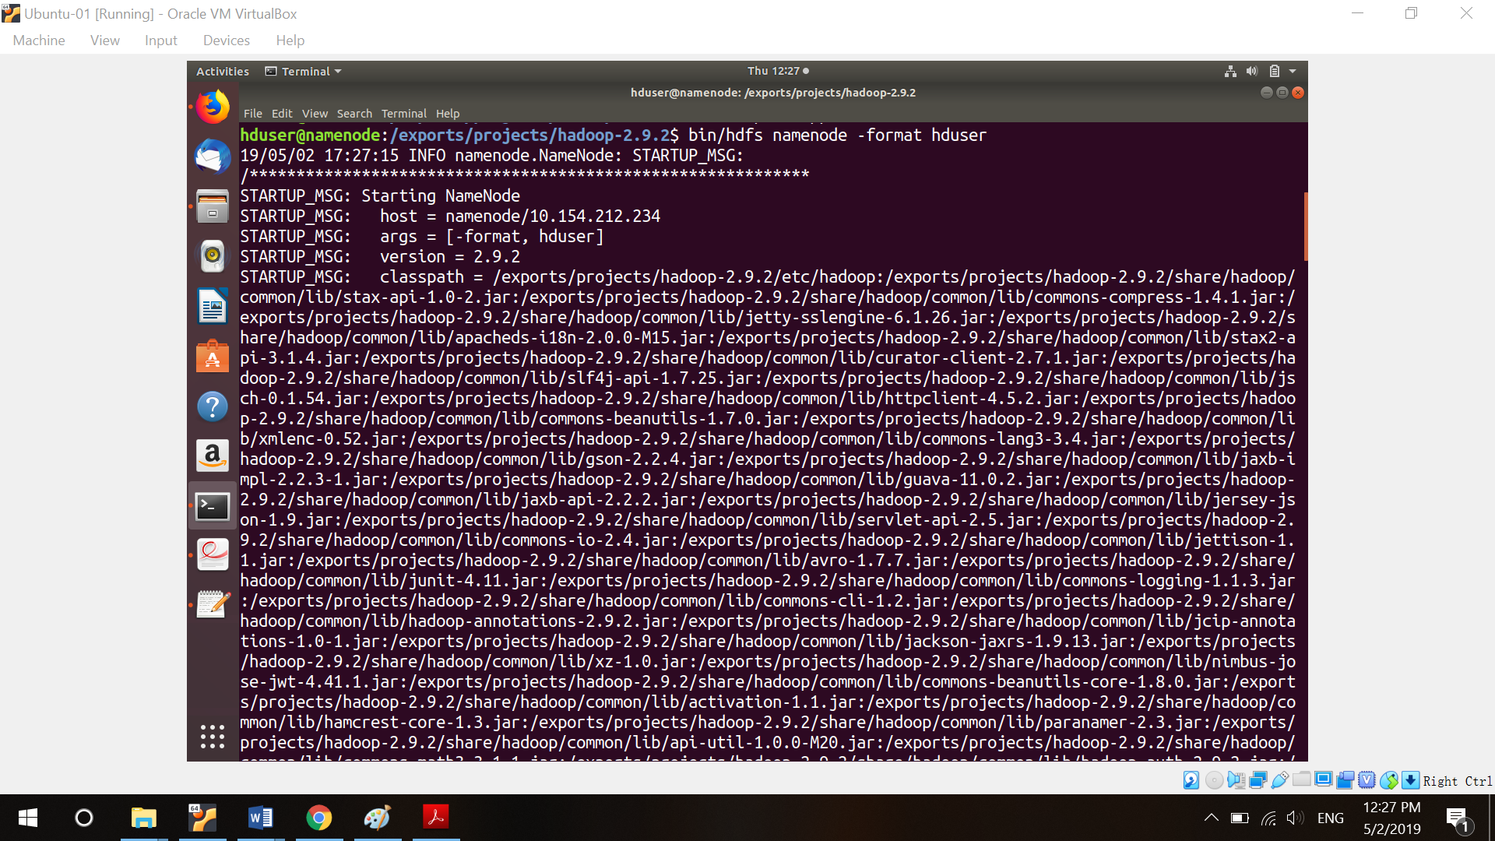

(l) Start dfs.

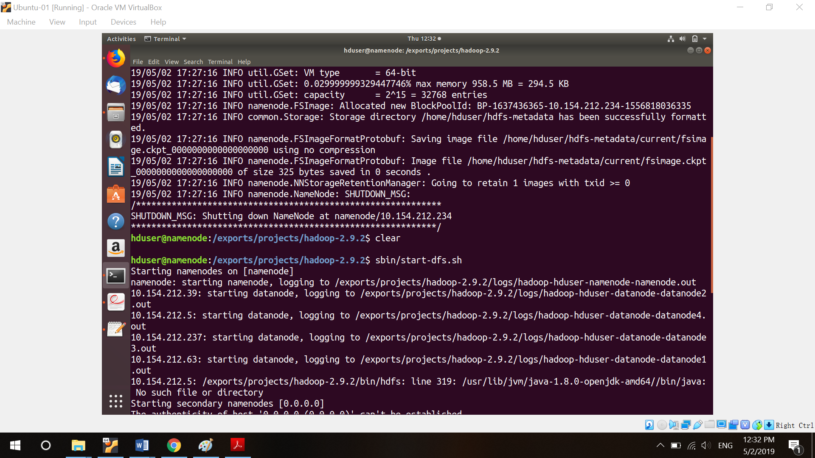

(m) Start yarn.

**Hadoop Sort**

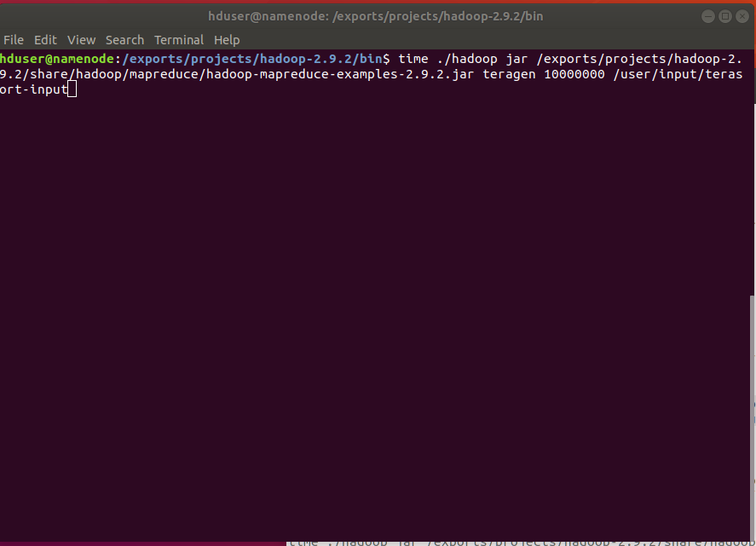

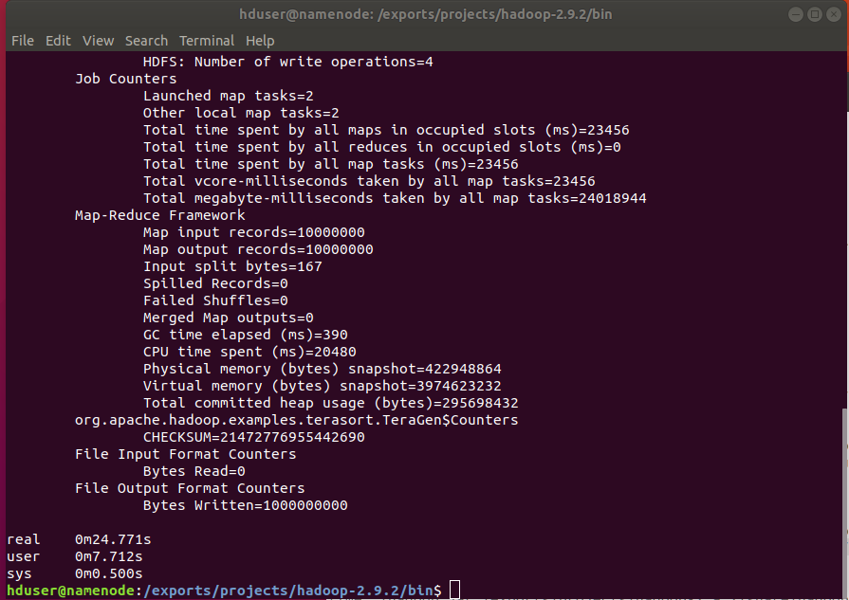

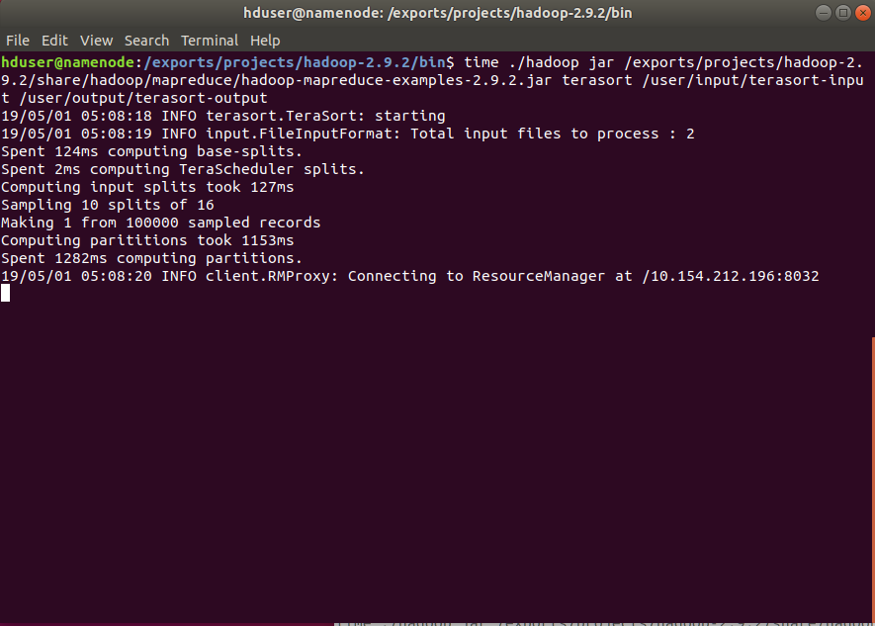

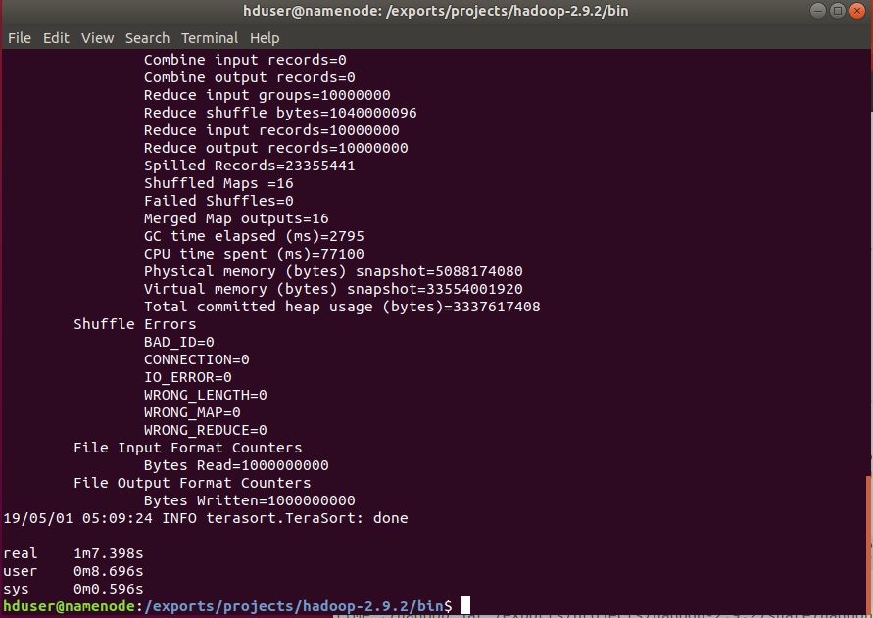

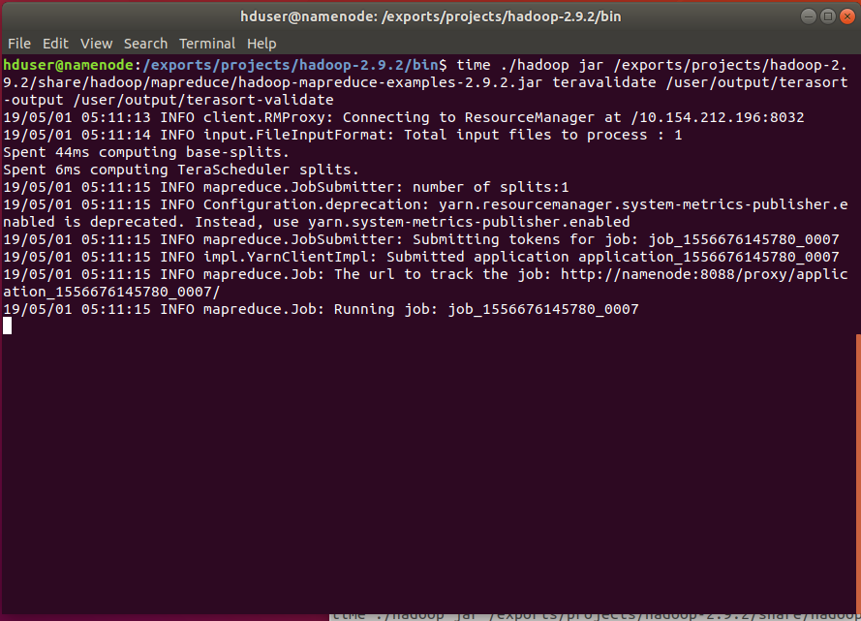

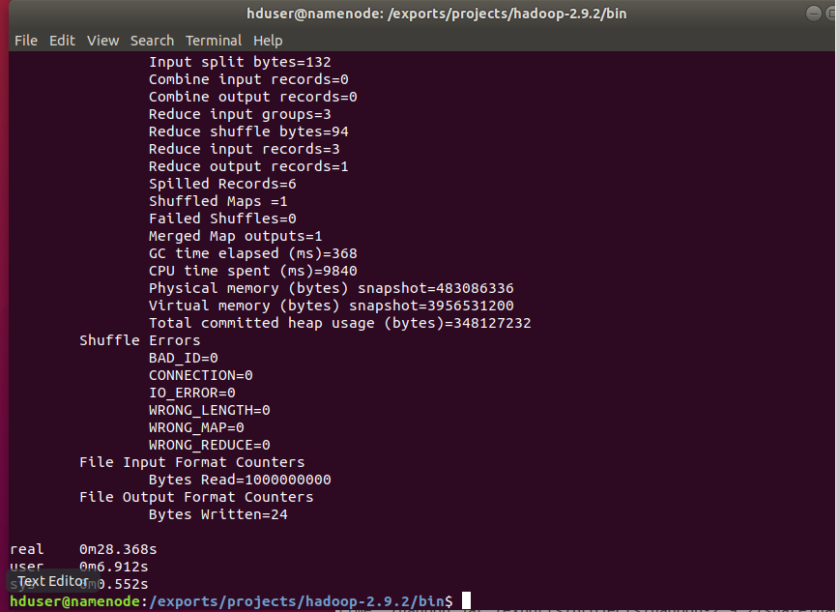

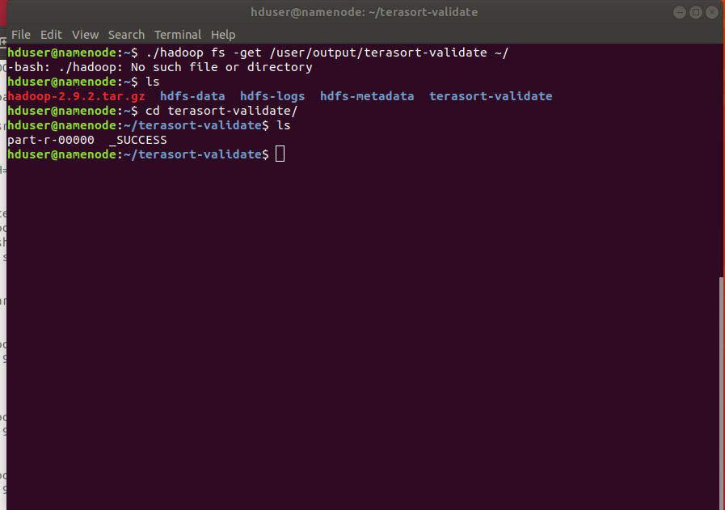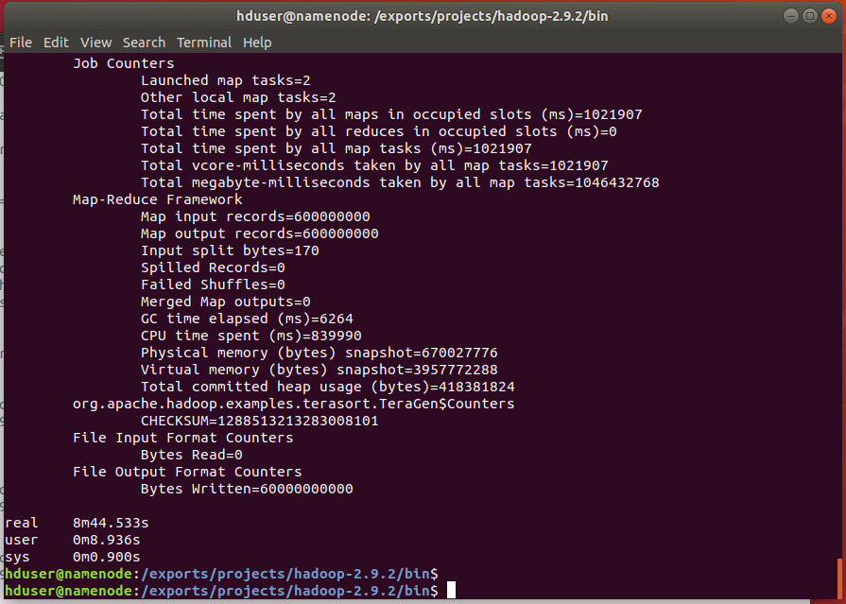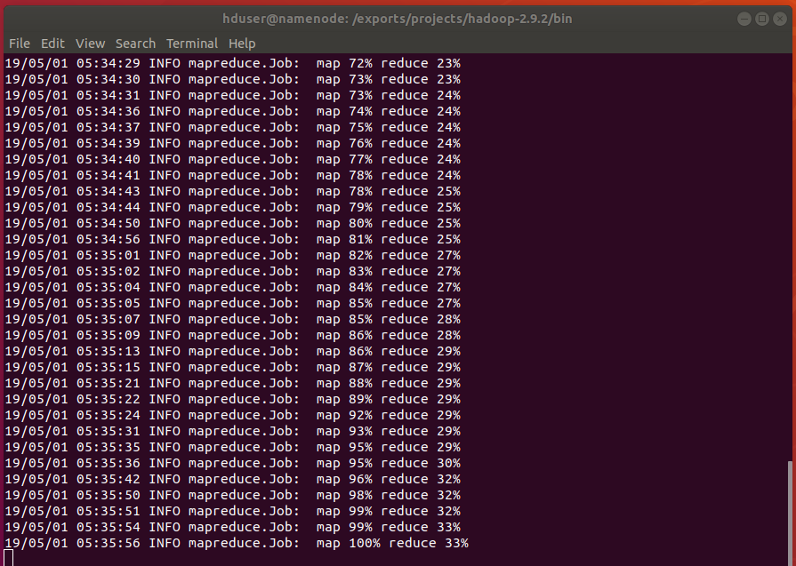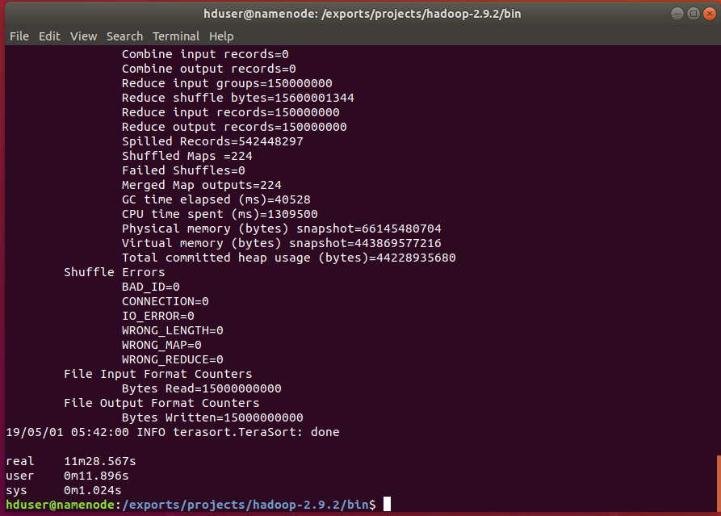

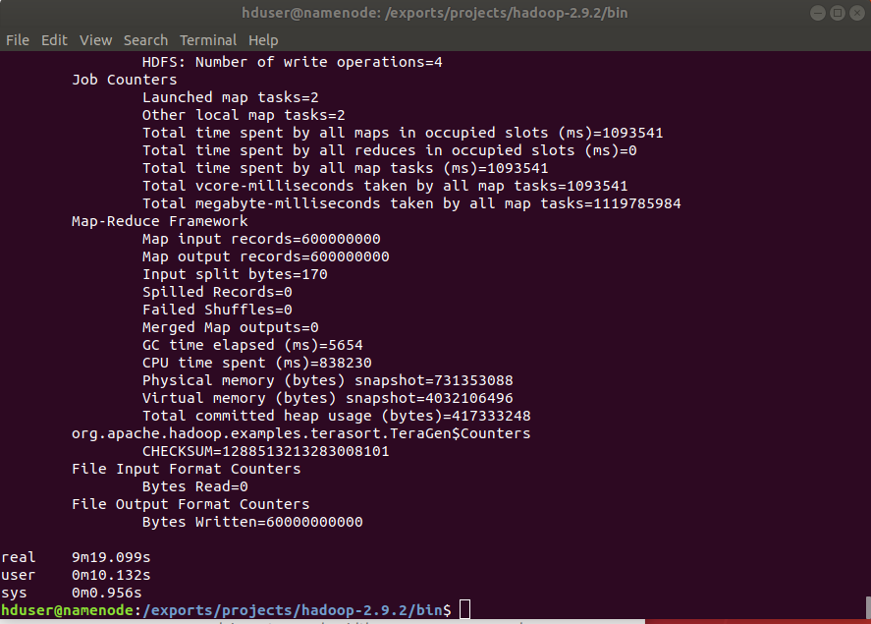

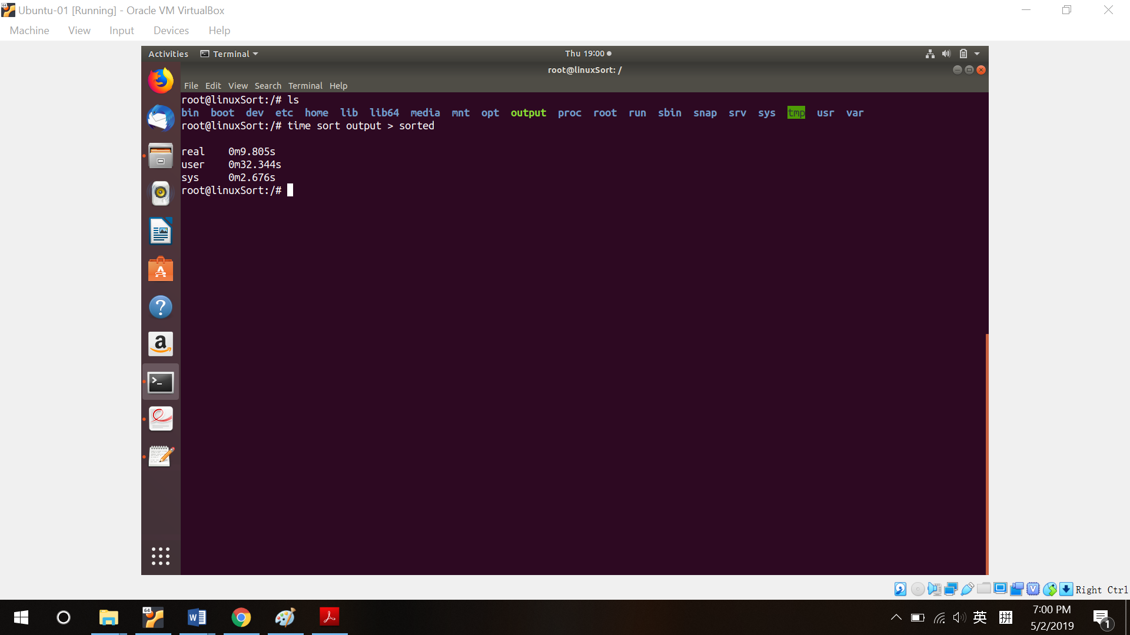

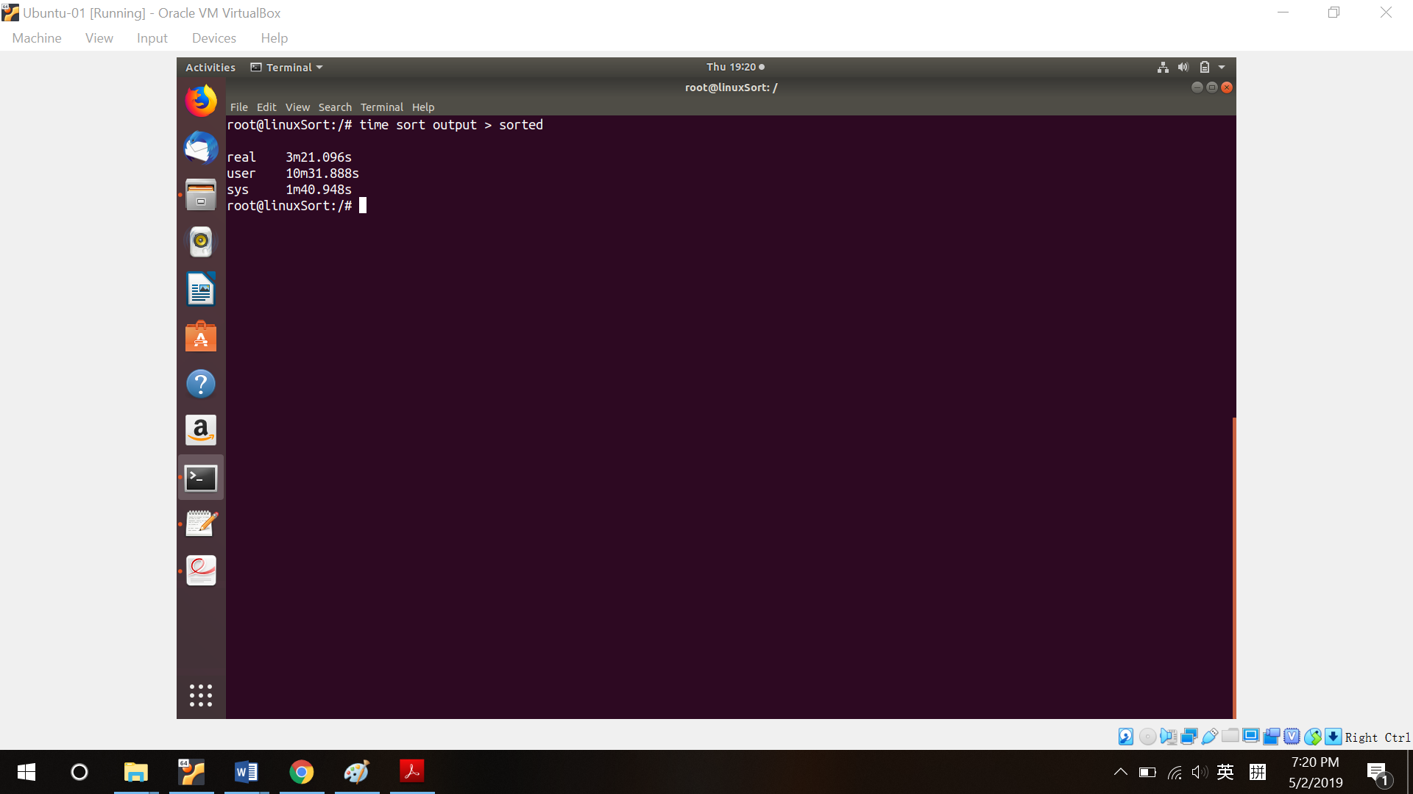

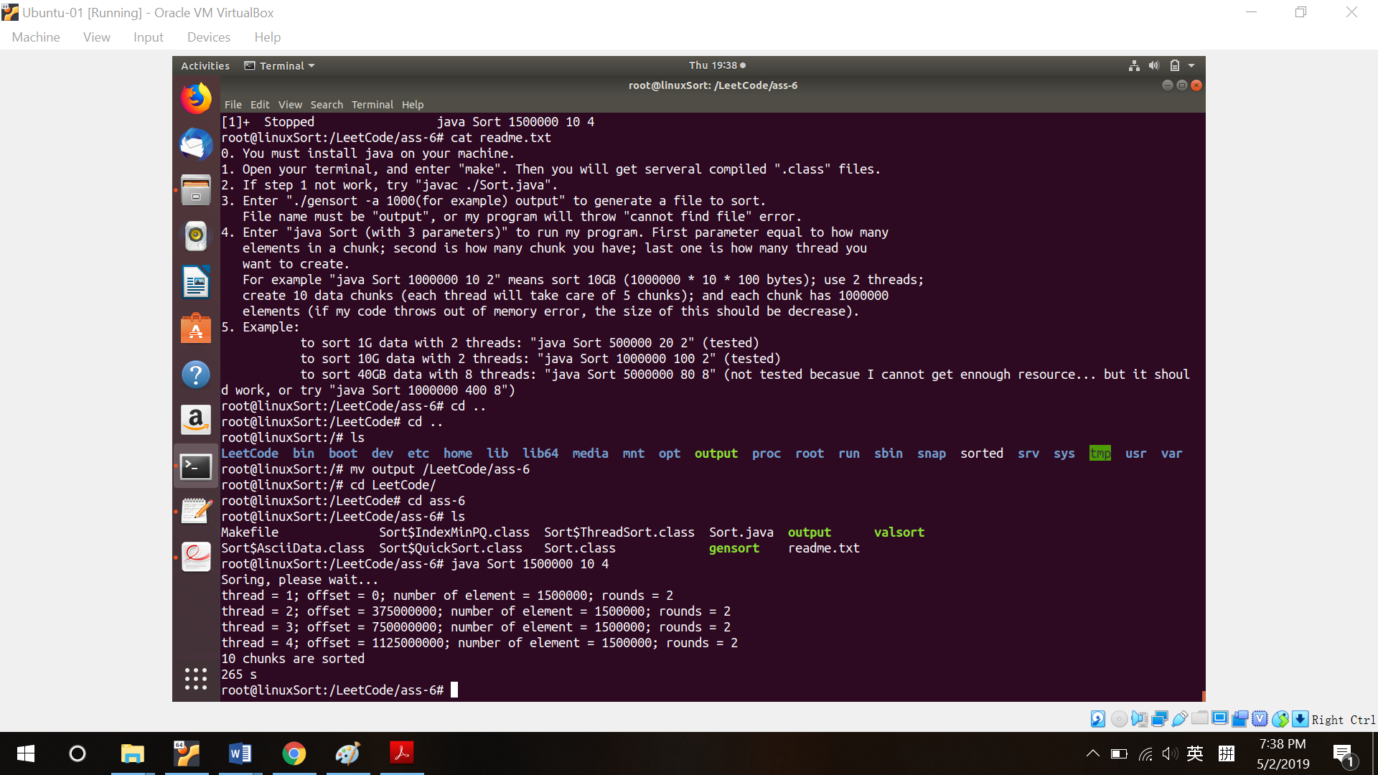

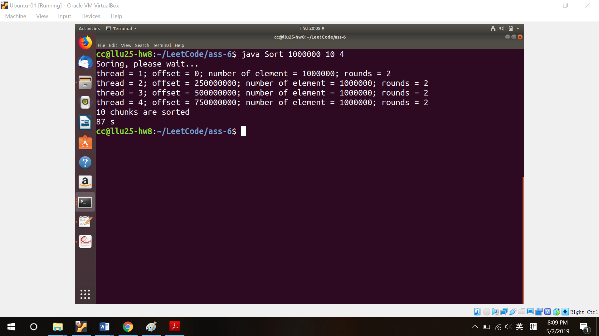

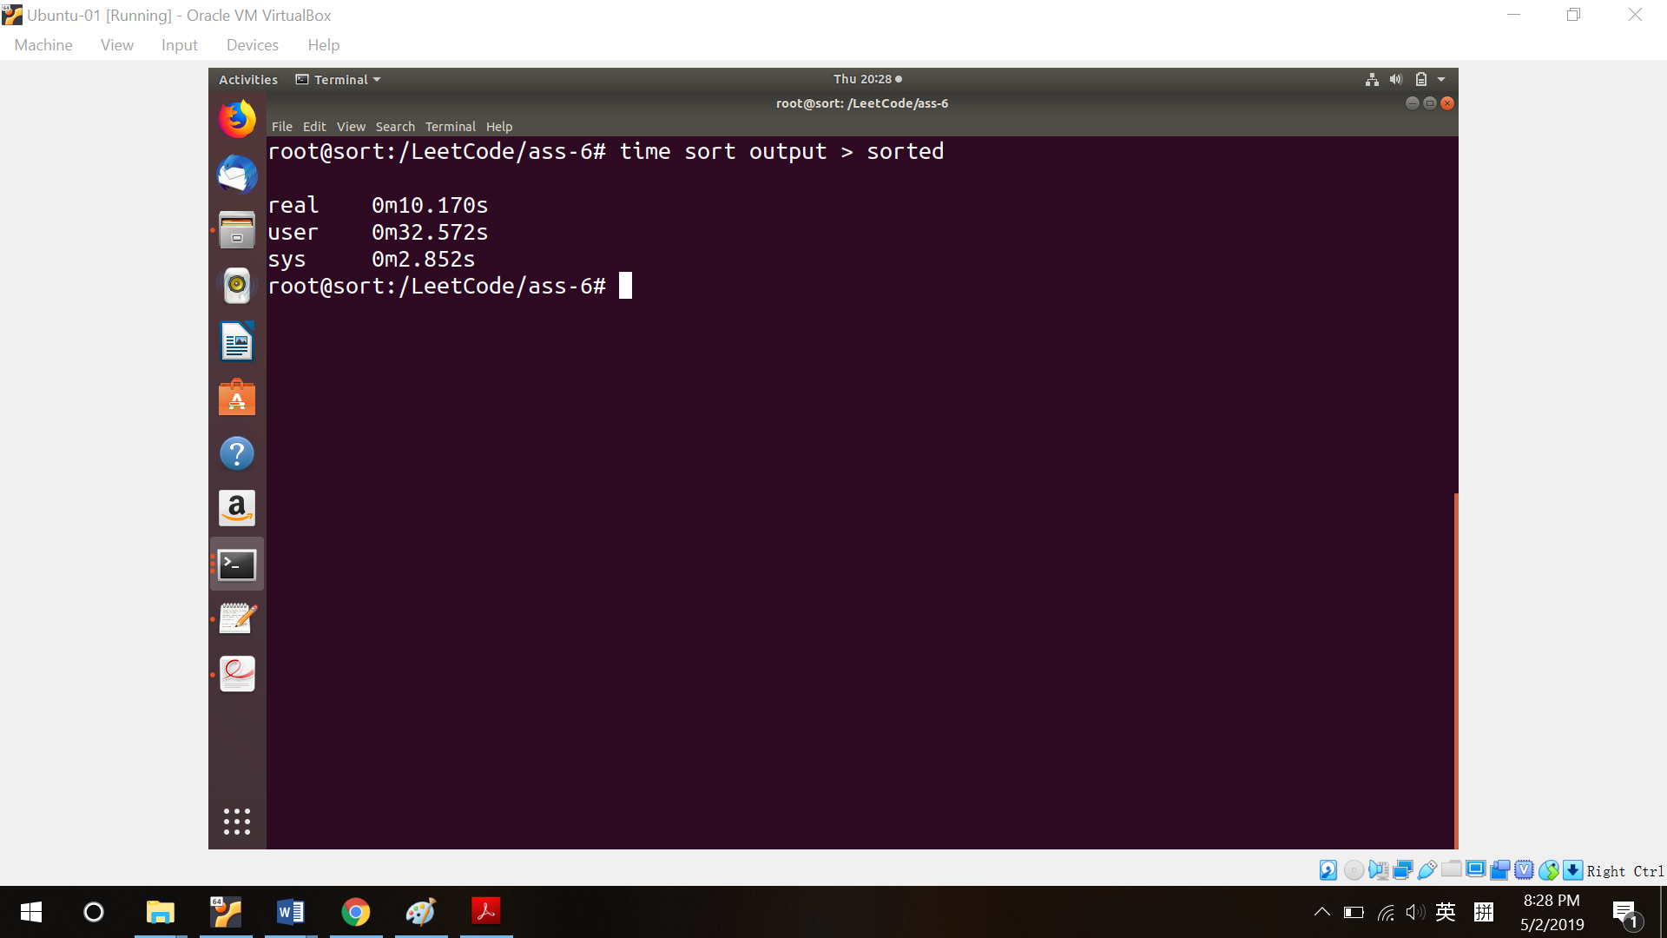

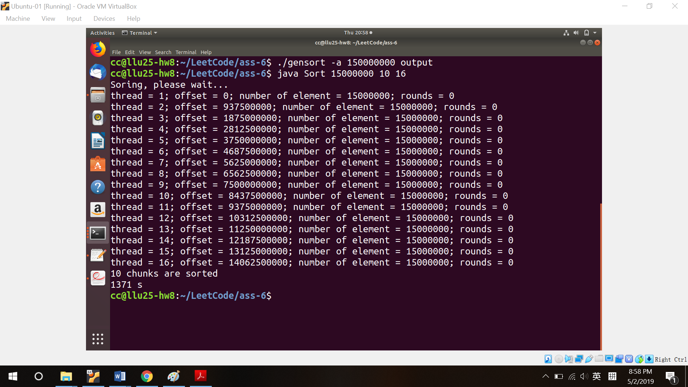

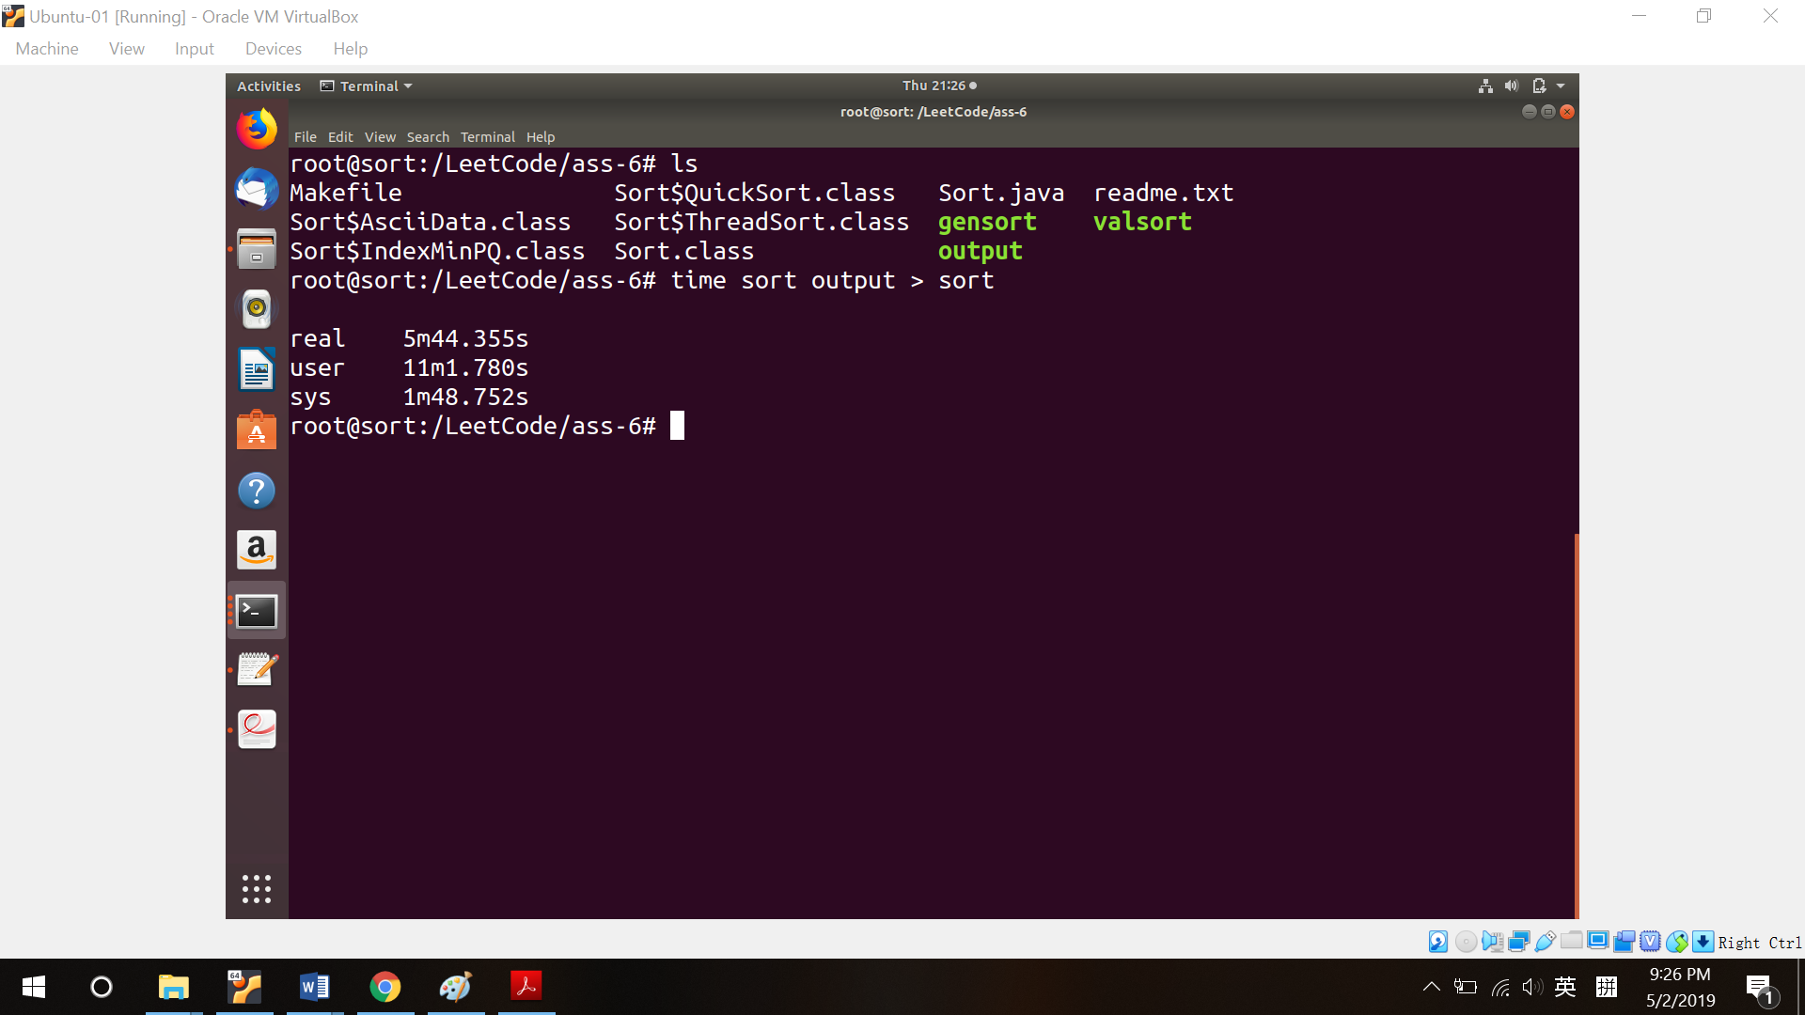

|  |  |  |  |  |
| --- | --- | --- | --- | --- |
| Experiment | Shred Memory | Linux | Hadoop Sort | Spark Sort |
| 1 small, 1G | 87s | 9.8s | - | - |
| 1 small, 15G | 265s | 201s | - | - |
| 1 large, 1G | 65s | 44s |  |  |
| 1 large, 15G | 1371s | 661s |  |  |
| 1 large, 60G | 5498s | 2735s |  |  |
| 4 small, 1G | - | - | 67s | 89s |
| 4 small, 15G | - | - | 525s | 934s |
| 4 small, 60G | - | - | 2486s | 4856s |